NAME: ________________________ DATE: ________________ CLASS: __________ / 60
SYSTEMS IN ACTION TAKE HOME TEST

A. Vocabulary Questions (9 marks)
Match the vocabulary words in Column 1 with the choices in Column 2. (Add the Letter.)
Column 1  Vocabulary Words |  | Column 2  Choices
1. friction |  | A. the ratio of output force to input force
2. energy |  | B. the ability to do work
3. mechanical advantage |  | C. a force that opposes the motion of an object

4. metric unit for mass |  | D. newton
5. work |  | E. the amount of matter in an object
6. gravity |  | F. action-at-a-distance force
7. kinetic energy |  | G. kilogram
8. metric unit for force |  | H. energy of a moving object
9. mass |  | I. force × distance

B. Vocabulary Questions (10 marks)
Column 1  Vocabulary Words |  | Column 2  Choices
10. IMA |  | A. work a machine is designed to perform
11. pulley |  | B. the ratio of useful output work to input work
12. screw |  | C. an inclined plane wrapped around a rod
13. useful output work |  | D. the mechanical advantage of a machine without friction
14. efficiency |  | E. grooved wheel with a rope looped around it
15. non-mechanical system |  | F. replaces human workers with machines
16. consumer |  | G. involves analysis of numerical data
17. automated system |  | H. uses goods or services provided by the system
18. quantitative assessment |  | I. the procedures, processes & people needed to perform a task
19. qualitative assessment |  | J. analysis made by observations

C. Matching Questions (6 marks)

Column 1  Words |  | Column 2  Choices
20. teeter-totter |  | A. second-class lever
21. IMA < 1 |  | B. wheel and axle
22. water tap |  | C. third-class lever
23. nail |  | D. ramp
24. The output force is in the same direction as & closer to the fulcrum than the input force. |  | E. wedge
25. The input force is always less than the output force. |  | F. first-class lever

D. Matching Questions (6 marks)
Column 1  Words |  | Column 2  Choices
26. non-mechanical system |  | A. output performed per unit of time
27. productivity |  | B. effect on people’s lives
28. efficiency |  | C. effect on the biotic and abiotic elements of an ecosystem
29. societal impact |  | D. effect on the money aspect of a system
30. environmental impact |  | E. performs a task without transferring forces
31. economic impact |  | F. the time and effort needed to produce an item

E. Matching Questions (10 marks)
Column 1  Vocabulary Words |  | Column 2  Choices
32. IMA of a ramp |  |  | A. component of a non-mechanical system
33. contact force |  |  | B. F_{out}/F_{in}
34. wedge |  |  | C. hybrid car gets 4.7 L/100 km
35. MA of a lever |  |  | D. heat
36. weight |  |  | E. lubricant
37. consumer |  |  | F. l/h
38. work done by friction |  |  | G. friction
39. IMA of a doorknob |  |  | H. r_{w}/r_{a}
40. increases efficiency |  |  | I. inclined plane that penetrates an object
41. quantitative assessment |  |  | J. action-at-a-distance force

32. How has the car affected the way people live? (4 marks)

33. You need to replace your car because it is getting old. Indicate what features of a new car you would look for that would lessen its impact on the environment. (3 marks)

34. Identify the lever shown below, and determine its ideal mechanical advantage. (3 marks)

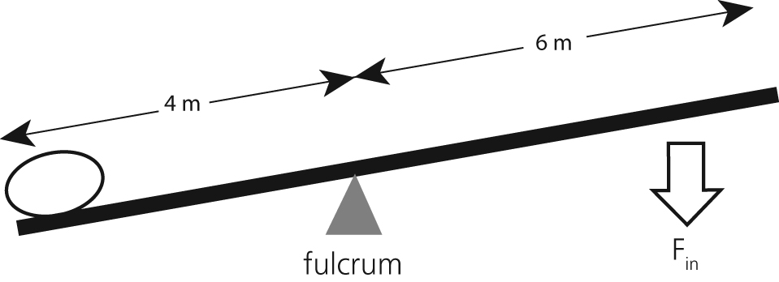

35. Draw a diagram of a pair of pliers. Label the location of the input force, output force & fulcrum. Make a statement about the IMA of this simple machine. (3 marks)

36. An 80 N crate is pushed up a ramp as shown in the diagram below.
Use the information in the diagram to determine the efficiency of the system. (3 marks)
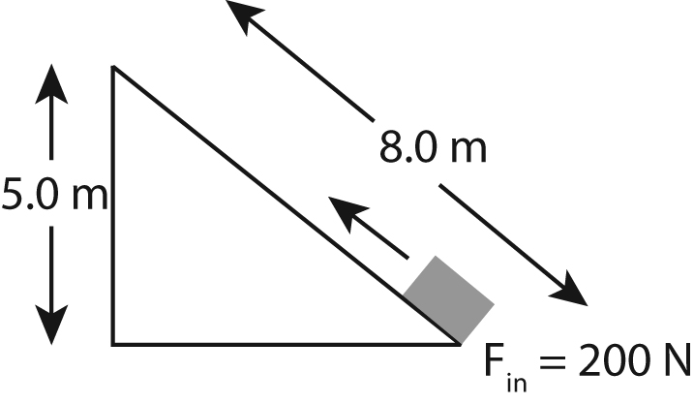

37. An electrical motor is tested and found to be 76 % efficient. If the input work is 400 J, what is the motor’s output work? (3 marks)

