SYSTEMS IN ACTION
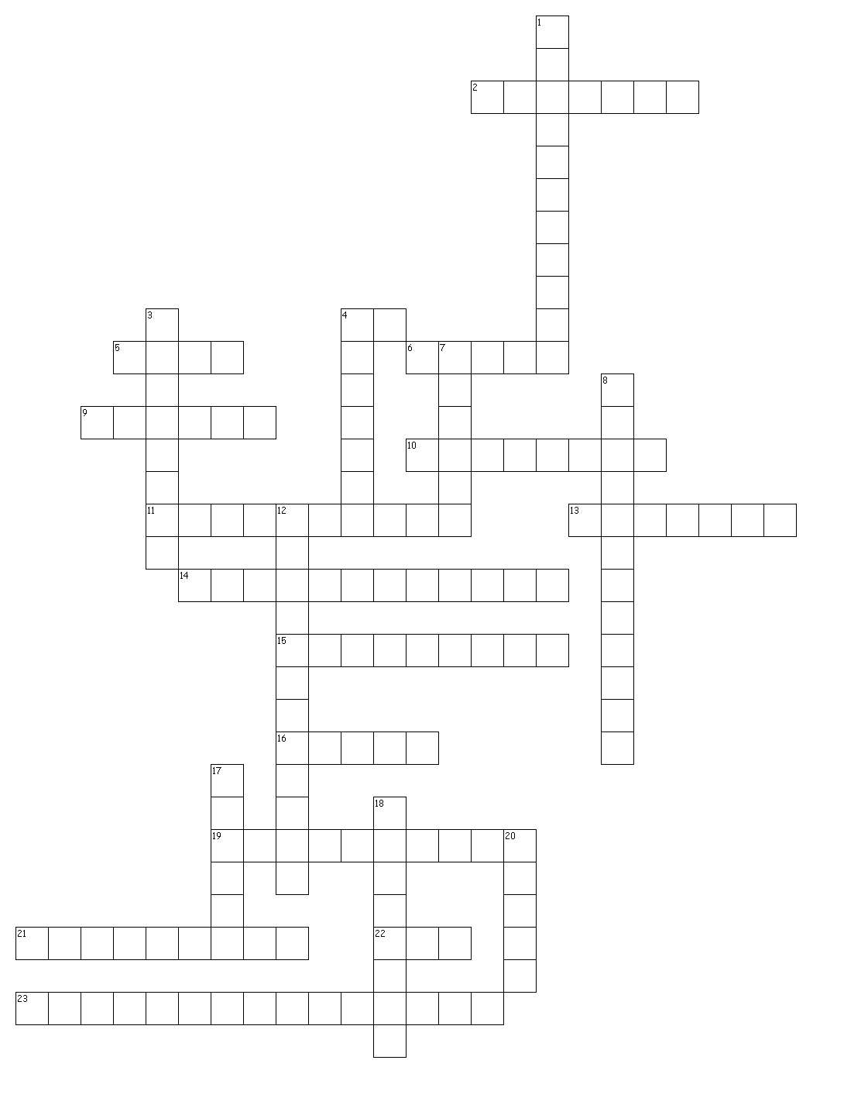

ACROSS
2. force of attraction between two objects because of their mass
4. amount by which a machine can multiply an input force; output force (Fout) / input force (Fin)
5. amount of effort expended when a force causes an object to move a distance & energy is transferred
6. simple machine consisting of an inclined plane that travels through an object or material
9. disk that moves inside a cylinder
10. force that opposes the relative motion of an object
11. measurement of the useful work done by a machine compared to the work needed to operate the machine
13. point at which a lever is supported
14. assessment analysis of numerical data
15. a system that replaces human workers with machines controlled by a computer
16. push or pull that acts on an object; measured in Newtons (N)
19. a system of physical parts that interact with each other & function as a whole to complete tasks
21. part of a system
22. mechanical advantage of a machine that has no friction
23. energy that is stored

DOWN
1. assessment analysis made by observation
3. individual who uses the goods or services provided by a system
4. any mechanical system that reduces the force required to accomplish work
7. ability to do work
8. amount of output that is produced per unit of time
12. force that acts between objects that are touching
17. type of machine that requires the application of a single force to do work
18. simple machine consisting of a sloped plane on which an object can move. Eg Ramp.
20. simple machine made up of a rigid bar that is supported at one point, the fulcrum

