EFFICIENCY OF SIMPLE MACHINES 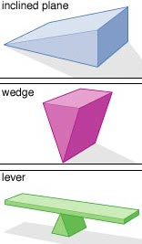

a) perpetual motion machine | n) 100
b) heat | o) 37.5
c) useful work / output work | p) length / distance
d) work needed / input work | q) height
e) useful output work | r) 75%
f) forward motion | s) 22%
g) input work | t) electric car
h) heat | u) solar cell or solar panel
i) less than | v) 10
j) lubricant | w) 5
k) rub | x) heat
l) oil or grease or water | y) lower / 30 °C
m) perfectly or 100%

