Name: Date:

Particle Model of Matter

1. What is a model?
____________________________________________________________

2. The particle model of matter is used to help___________________________ ____________________________________________________________

3. What are solids, liquids and gases made up of? ____________________________________________________________

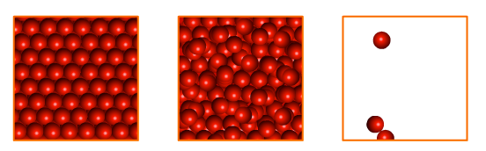
4. Label the following diagrams:

_________ _________ ________

5. Complete the following sentences:

  - Particles in solids are held tightly together in a _____________ pattern. Spaces between particles are ______________. The particles in a solid _____________.

  - Particles in liquids are able to ___________ around & past each other. The spaces between particles are small. Particles in a liquid vibrate, ___________ & move around.

  - Particles in gases are able to move ___________. The spaces between particles are ___________. Particles in gas move quickly in ____________ lines.
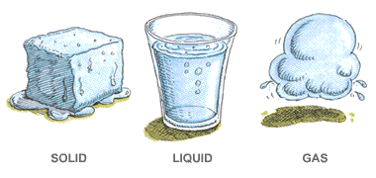

6. When sugar dissolves into water it forms a mixture called a solution.
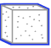
a. What is the solvent in this situation? Why? ___________________________ ________________________________________________________________
________________________________________________________________
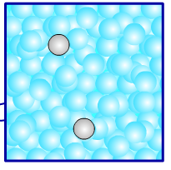
b. What is the solute in this situation? Why? ____________________________ ________________________________________________________________________________________________________________________________
c. Label the solvent and the solute in the diagram below.
7. Circle T for True or F for False.
- A solution contains particles of the solute and particles of the solvent evenly distributed throughout the mixture.
T F
T F
- A dilute solution has a large mass of dissolved solute for a certain amount of solvent.
- The concentration of a solution is the quantity of solute that is dissolved in a certain quantity of solvent.
T F
T F
- Particles move faster at higher temperatures.

8. Show the particles in the two solutions. Add labels to your diagrams.

Dilute sugar-water solution Concentrated sugar-water solution

9. What are some important things you learned while completing this activity?
________________________________________________________________________________________________________________________________________________________________________________________________________________________________________________________________________________________________________________________________

