COMMON ACIDS 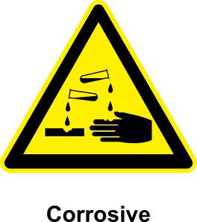

Acetylsalicylic | Boric | Acetic | Nitric
Carbolic | Carbonic | Sulphuric | Hydrochloric
Hydrofluoric | Hydrosulfuric | Lactic | Phosphoric
Formic | Tannic | Fluoric | Cloric
Oxalic | Nitrous | Citric | L-ascorbic

COMMON ACIDS

ASA – aspirin | Insecticide | Vinegar | Fertilizers, rocket fuel, explosives
Mild disinfectant | Soda pop / Acid rain | Car battery | Stomach
 |  | Milk, muscles
Antibacterial agent in livestock feed | Staining wood colours
Cleans rust / stains off wood & rugs | Laughing gas | Orange juice | Vitamin C

