COMMON ACIDS 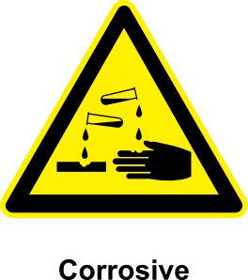

Acetylsalicylic ASA - aspirin | Boric  Insecticide | Acetic  Vinegar | Nitric  Fertilizers, rocket fuel, explosives
Carbolic  Mild disinfectant | Carbonic  Soda pop / Acid rain | Sulphuric  Car battery | Hydrochloric  Stomach
Hydrofluoric | Hydrosulfuric | Lactic  Milk, muscles | Phosphoric
Formic  Antibacterial agent in livestock feed | Tannic  Staining wood colours | Fluoric | Cloric
Oxalic  Cleans rust / stains off wood & rugs | Nitrous  Anesthesia  (Laughing gas) | Citric  Orange juice | L-ascorbic  Vitamin C

USES OF COMMON ACIDS – TEST / 15

ASA - aspirin | Insecticide | Vinegar | Fertilizers, rocket fuel, explosives
Mild disinfectant | Soda pop / Acid rain | Car battery | Stomach
 |  | Milk, muscles | 
Antibacterial agent in livestock feed | Staining wood colours |  | 
Cleans rust / stains off wood & rugs | Anesthesia  (Laughing gas) | Orange juice | Vitamin C

Place the acid where it is used in a common substance. Not all will be used.

Acetic Acetylsalicylic Tannic

L-ascorbic Nitric Hydrochloric

Lactic Sulphuric Oxalic

Carbolic Citric Phosphoric

Carbonic Fluoric Nitrous

Formic Boric Cloric

 COMMON ACIDS 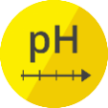 /15
- Write an example of their common application (use).
Acetylsalicylic - Boric -
Acetic - Nitric -
Carbolic - Carbonic -
Sulphuric - Hydrochloric -
Lactic - Formic -
Tannic - Oxalic -
Nitrous - Citric -
L-ascorbic -

