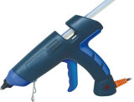 PERFECT CUBE QUESTIONS (10cm x 10cm x 10cm)

Please answer in FULL sentences (minimum 2 sentences / diagrams may help.)

- How would you build the cube if you had to use metal or plastic?

- How would you change the directions to make it easier to build?

- What would you have to do to build a rectangular prism?

- What other tools would be useful when building a cube?

- What could you use your finished product for?

- How could you apply the skills you used to the real world? Write a paragraph response. (minimum 5 sentences)

- Include at least one technical drawing. – (measurements, horizontal labels, List the view. In pencil, on graph or blank paper).

