APPLICATIONS OF HEAT KNOWLEDGE
CLINICAL THERMOMETER
It uses the expansion & contraction of a liquid to measure temperature. It’s sensitive to small changes in temperature & measures within a few degrees of body temperature (37 °C).
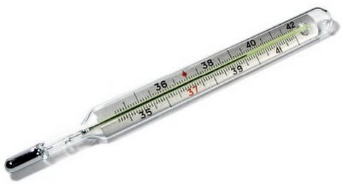

THERMOCOUPLE
A thermocouple is a thermometer that does not use expansion or contraction to measure temperature. It uses electricity to measure high temperatures. (Pottery kiln or a blast furnace).
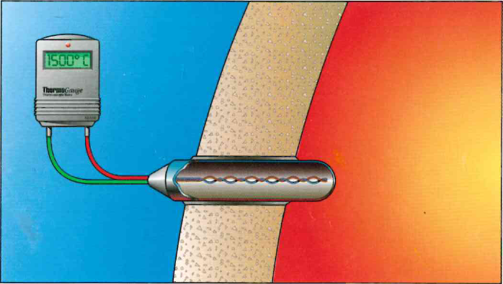

FOSSIL FUELS
A main source of heat is the burning of fossil fuels - oil, natural gas, or coal. Burning these fuels transforms stored chemical energy into thermal energy.

COAL 
Coal is the most abundant fossil fuel. It is the largest source of energy for generating electricity. Coal is burned to boil water, steam rises, spins a turbine & creates electricity.

RECLAMATION: Putting land back to its original condition after taking natural resources.

A coal mine before & during the reclamation process
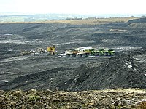
In 2007 - During In 2017 - After

SULFUR DIOXIDE
Sulfur dioxide molecule. (SO₂) is a colourless gas produced by burning fossil fuels & from erupting volcanoes. Sulfur dioxide irritates the eyes, nose & throat. It affects asthma sufferers. It is one of the components in acid rain.

THERMOSTAT
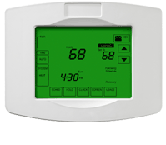A programmable thermostat adjusts the temperature automatically. The timer lets you pre-set temperatures for different times of the day.
Thermals
A thermal is a column of rising air created by uneven heating of the air near the ground. Thermals are an example of convection. Birds take advantage of rising currents to migrate. Gliders use thermals to fly.

