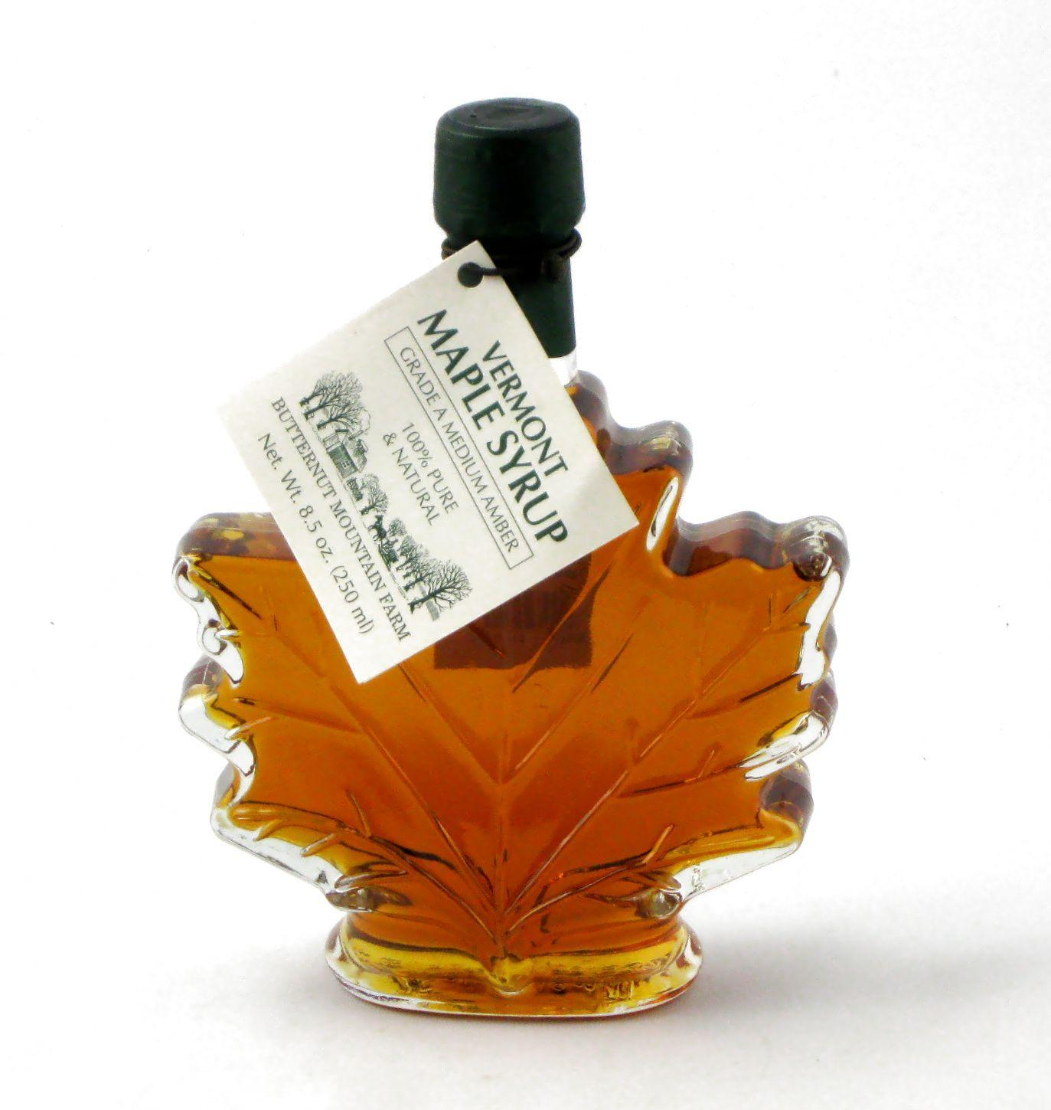 Viscosity Activity
Go to this web site: https://resources.elearningontario.ca/



The User Id is: ocdsbteacher
Password: oerbt

Click: I AGREE at the bottom.
Click: SEARCH  at right hand side

Type in: VISCOSITY GO WITH THE FLOW
It’s the second “hit”. - 2nd listed activity.

Go with the Flow: Studying Viscosity: Grade 8 Science & Technology (Catholic)
Resource ID: ELO1367950

- Complete the Interactive Learning Object.
- Take your time. Carefully Read all text or you will have to write it ALL out into your binder notes!

