 | CELLS ANTICIPATION GUIDE
T F |  | - The cell is the basic unit of life.
T F |  | -  An organelle is larger than a cell.
T F |  | - Vacuoles do not have the same function as chloroplasts.
T F |  | - Mitochondria are known as the powerhouse of the cell.
T F |  | - All cells are created from existing cells by the process of cell division. 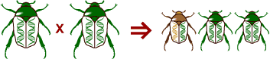
T F |  | - The existence of cells was unknown till the late 1800’s when the “light telescope” was invented. 
T F |  | - Only animal cells have cytoplasm. 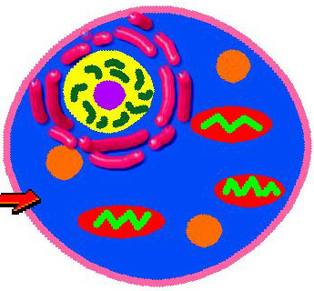
T F |  | - All organisms must grow, eat, move, excrete, respire, reproduce and sense things.
T F |  | - Osmosis is a special type of diffusion. 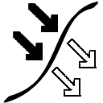
T F |  | - Diffusion is the movement of gas or liquid from an area of high concentration to an area of low concentration.
T F |  | - The 5 types of animal tissue are: muscle, epithelial, nervous & connective.
T F |  | -  There are more human cells in your body than bacterial cells. (Ratio of 100:1)
T F |  | - A selectively permeable membrane seals a cell & allows no materials to pass in or out. 
T F |  | - The nucleus is not the control center of the cell.
T F |  | - The movement of water through an impermeable membrane is the process of osmosis.

 | CELLS ANTICIPATION GUIDE – ANSWERS!
T |  | - The cell is the basic unit of life.
F |  | - An organelle is larger than a cell.
T |  | - Vacuoles do not have the same function as chloroplasts.
T |  | - Mitochondria are known as the powerhouse of the cell.
T |  | - All cells are created from existing cells by the process of cell division.
F |  | - The existence of cells was unknown till the late 1800’s 1600’s when the “light telescope” was invented.
F |  | - Only animal cells have cytoplasm.
T |  | - All organisms must grow, eat, move, excrete, respire, reproduce and sense things.
T |  | - Osmosis is a special type of diffusion.
T |  | - Diffusion is the movement of gas or liquid from an area of high concentration to an area of low concentration.
F |  | - The 5 types of animal tissue are: muscle, epithelial, nervous & connective.
F |  | - There are more human cells in your body than bacterial cells. (Ratio of 100:1)
F |  | - A selectively permeable membrane seals a cell & allows no materials to pass in or out.
F |  | - The nucleus is not the control center of the cell.
F |  | - The movement of water through an impermeable membrane is the process of osmosis.

