SPORTS PROBABILITY

Baseball star Jumpin’ Jack Flazio’s batting average is .300
- Estimate the probability of Flazio getting a hit.
- Estimate the probability of Flazio not getting a hit.
- How many hits, on average, will Flazio get in 40 at-bats.

Sidney Crosby has a 23.3% chance of scoring a goal on every shot that he takes.
- Estimate how many shots he needs to get 30 goals.
- If he gets five shots in one game, is he likely to get at least one goal? Explain.
____________________________________________________________________________________________________________________________________________
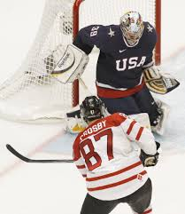

Caitlin Clark has a three-point percentage of 32.9%.
- If she gets three opportunities in a single game to score a three-point shot, is she likely to get one? Place your answer on the probability line below.
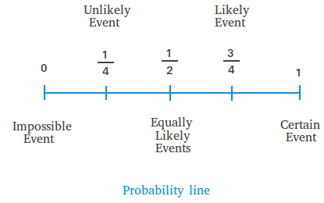

In 2025, Lionel Messi has thirty-five goals in thirty-three games played.
- In the same league, how likely is he to score a goal in his first game of 2026?
Nishiyama is ranked #1 in men’s kata. He has recently scored 26/30, 27/30 and 25/30.

- In theory, he likely will get a score of 26/30 after performing his next kata; however, is it possible for him to get a score lower than 25? Explain using course terminology.

________________________________________________________________________________________________________________________________________________________

Linus Ullmark typically saves 9/10 shots that he faces.
- If he faces 1000 shots, how many goals will he let in? Show as a decimal, fraction and percent.

- If he faces 1000 shots, how many shots will he save? Show as a decimal, fraction and percent.

Summer McIntosh holds the record for the fastest 400m freestyle with 3:54.18.
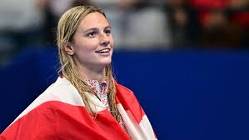
- Her 400m times range from 3:54-4:02. If she performs at her maximum potential and her opponents remain at the same difficulty, what is the chance that she will win the event?
SPORTS PROBABILITY - ANSWERS

Baseball star Jumpin’ Jack Flazio’s batting average is .300
- Estimate the probability of Flazio getting a hit.
30%, 0.3, 3/10
- Estimate the probability of Flazio not getting a hit.
70%, 0.7, 7/10
- How many hits, on average, will Flazio get in 40 at-bats.
40 x 0.30 = 12
Sidney Crosby has a 23.3% chance of scoring a goal on every shot that he takes.
- Estimate how many shots he needs to get 30 goals.
1/0.233 x 30 = 129 (rounded) - you must have a whole number.
- If he gets five shots in one game, is he likely to get at least one goal? Explain.
Yes, he is likely to get a goal in the game. Crosby shoots with a 23.3% accuracy. When the percentage is added up, it is greater than 100%. It is not guaranteed due to experimental probability not always equalling theoretical probability.
Caitlin Clark has a three-point percentage of 32.9%.
- If she gets three opportunities in a single game to score a three-point shot, is she likely to get one? Place your answer on the probability line below.
Add up 32.9% on three shot opportunities. You will realize that the event of her getting one shot in is quite high, but not certain. Place your line after likely, before certain.
In 2025, Lionel Messi has thirty-five goals in thirty-three games played.
- In the same league, how likely is he to score a goal in his first game of 2026?
Add up Messi’s goals per game average. You will realize that 55/53 is greater than a goal per game; however, experimental probability means that it is not quite certain. Your line should be just before certain, showing that it is very likely but not guaranteed.
Nishiyama is ranked #1 in men’s kata. He has recently scored 26/30, 27/30 and 25/30.

- In theory, he likely will get a score of 26/30 after performing his next kata; however, is it possible for him to get a score lower than 25? Explain using course terminology.

It is possible to get lower than twenty-five. The theoretical probability says that he will get twenty-six on his next attempt; however, experimental probability can often differ from theoretical. It is possible for him to get any number from 0/30 to 30/30.

Linus Ullmark typically saves 9/10 shots that he faces.
- If he faces 1000 shots, how many goals will he let in? Show as a decimal, fraction and percent.

1/10, 0.1, 10%

- If he faces 1000 shots, how many shots will he save? Show as a decimal, fraction and percent.
9/10, 0.9, 90%
Summer McIntosh holds the record for the fastest 400m freestyle with 3:54.18.
- Her 400m times range from 3:54-4:02. If she performs at her maximum potential and her opponents remain at the same difficulty, what is the chance that she will win the event?
Your line should be ON CERTAIN. Summer is performing at her maximum potential. Her opponents are remaining at the same skill level. Since her maximum potential is the world record, she is guaranteed to win the event.

