**Ch 3 - Fractions Practice Test**

**True/False**

*Indicate whether the sentence or statement is true or false.*

*If false, write the corrected statement in the space provided.*

____ 1.  of the hexagon is covered.

_____________________________________________________________________

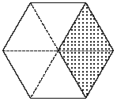

____ 2. The subtraction sentence represented by the diagram is   .

_____________________________________________________________________

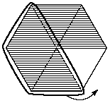

____ 3. You can find a common denominator for any pair of fractions.

_____________________________________________________________________

____ 4. There is **no** common denominator between 1 and 50 for this group of fractions: , , and .

_____________________________________________________________________

____ 5.  is smaller than .

_____________________________________________________________________

____ 6. The smallest fraction in the group of fractions , , and  is .

_____________________________________________________________________

____ 7. The product of 4   is greater than the product of 5  .

_____________________________________________________________________

____ 8. The sum of    is greater than .

_____________________________________________________________________

____ 9. The difference of    is the same as the sum of     .

_____________________________________________________________________

**Multiple Choice**

*Identify the letter of the choice that best completes the statement or answers the question.*

____ 10. What fraction of the hexagon is covered?

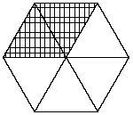

|  |  |  |  |
| --- | --- | --- | --- |
| a. |  | c. |  |
| b. |  | d. |  |

____ 11. How much more of the left hexagon is covered than the right hexagon?

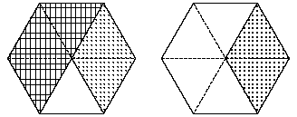

|  |  |  |  |
| --- | --- | --- | --- |
| a. |  | c. |  |
| b. |  | d. |  |

____ 12. Between 1 and 40, how many common denominators do the fractions  and  have?

|  |  |  |  |
| --- | --- | --- | --- |
| a. | 1 | c. | 3 |
| b. | 2 | d. | 4 |

____ 13. Which fraction is the smallest in this group of fractions: , , , and ?

|  |  |  |  |
| --- | --- | --- | --- |
| a. |  | c. |  |
| b. |  | d. |  |

____ 14. What is the result of     ?

|  |  |  |  |
| --- | --- | --- | --- |
| a. |  | c. |  |
| b. |  | d. |  |

**Matching**

*Match the correct term to each of the following descriptions.*

|  |  |  |  |
| --- | --- | --- | --- |
| a. | common denominator | f. | manipulative |
| b. | denominator | g. | improper |
| c. | numerator | h. | mixed |
| d. | repeated | i. | multiplication |
| e. | multiple | j. | equivalent |

____ 15. 5, 10, and 15 are examples of this for the number 5.

____ 16.  and  are an example of this type of fractions.

____ 17. , , and  are examples of this type of fraction.

____ 18. 12 and 24 are examples of this for the fractions , , and .

____ 19. 5 is this part of the fraction for fractions such as , , and .

____ 20. Marbles are an example of this type of tool that helps to visually understand mathematical concepts or skills.

**Short Answer**

*Write your answer in the space provided.*

21. Write a subtraction sentence to represent each diagram.

a)

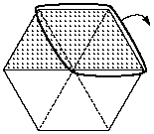

b)

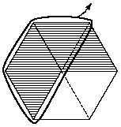

22. Find a common denominator for each pair of fractions. Rewrite each fraction with the common denominator.

a) , and 

b)  and 

c)  and 

23. Evaluate each of the following. Show your answer in the simplest form.

a) 4  

b) 7  

c) 2  

24. Find a common denominator for each pair of fractions. Rewrite each fraction with the common denominator, and evaluate.

a)   

b)   

c)   

25. Find the value of *x*.

a)  = 

b)   1 = 

26. What fraction does each group of diagrams represent? Show your answer as an improper fraction and as a mixed number.

a)

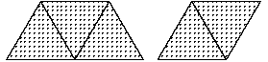

b)

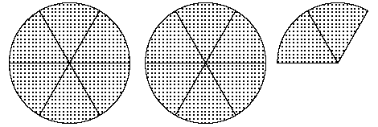

c)

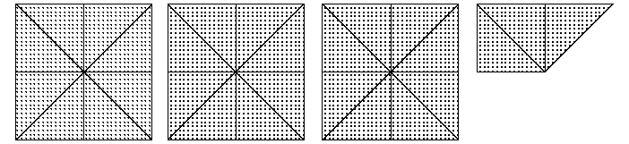

**Problem**

*Write your answer in the space provided.*

27. Ms. Lohan’s art class has decided to put some money together to buy her a birthday gift. There are 25 students in the class. They want to give her a paint set that includes: 10 brushes for $15.00, 3 canvas boards for $35.00, 2 sketchpads for $10.00, and 15 sketch pencils for $5.00.

a) What is the total cost of the paint set?

b) Write a fraction to represent the cost of each item out of the total cost. Write each fraction in its simplest form.

c) Write a fraction to represent the cost of each item for one student.

d) Write an addition sentence for the group of fractions in part c). Find the amount of money each student has to contribute for the gift.

**Ch 3 - Fractions Practice Test**

**Answer Section**

**TRUE/FALSE**

1. ANS: F

 of the hexagon is covered.

DIF: Level 1 REF: Application OBJ: Section 3.1 STO: NSN-7m2

TOP: Number Sense and Numeration KEY: Fractions

2. ANS: T DIF: Level 2 REF: Application OBJ: Section 3.2

STO: NSN-7m2 TOP: Number Sense and Numeration KEY: Subtracting Fractions

3. ANS: T DIF: Level 2 REF: Knowledge/Understanding

OBJ: Section 3.3 STO: NSN-7m1 TOP: Number Sense and Numeration

KEY: Common Denominator

4. ANS: F DIF: Level 3 REF: Application OBJ: Section 3.3

**42** is the Common Denominator (6 x 7 = **42**, 3 x 14 = **42**, 2 x 21 = **42)**

5. ANS: F

 is greater than .

Rationale:

 = 

 = 

DIF: Level 3 REF: Application OBJ: Section 3.3 STO: NSN-7m1

TOP: Number Sense and Numeration KEY: Comparing Fractions

6. ANS: F

The smallest fraction in the group of fractions , , and  is .

Rationale:

A common denominator for , , and  is 336.

 <  < 

DIF: Level 4 REF: Application OBJ: Section 3.3 STO: NSN-7m1

TOP: Number Sense and Numeration KEY: Comparing Fractions

7. ANS: T DIF: Level 2 REF: Application OBJ: Section 3.4

STO: NSN-7m19 TOP: Number Sense and Numeration KEY: Multiplying Fractions

8. ANS: F

The sum of    is smaller than .

Rationale:

   =    = 

 =  = 

DIF: Level 3 REF: Application OBJ: Section 3.4 STO: NSN-7m1

TOP: Number Sense and Numeration KEY: Comparing Fractions

9. ANS: T DIF: Level 4 REF: Application OBJ: Section 3.4

STO: NSN-7m6 TOP: Number Sense and Numeration KEY: Adding/Subtracting Fractions

**MULTIPLE CHOICE**

10. ANS: A DIF: Level 1 REF: Application OBJ: Section 3.1

STO: NSN-7m2 TOP: Number Sense and Numeration KEY: Fractions

11. ANS: A DIF: Level 3 REF: Application OBJ: Section 3.1

STO: NSN-7m2 TOP: Number Sense and Numeration KEY: Comparing Fractions

12. ANS: C DIF: Level 3 REF: Application OBJ: Section 3.3

STO: NSN-7m11 TOP: Number Sense and Numeration KEY: Common Denominator

13. ANS: A DIF: Level 3 REF: Application OBJ: Section 3.3

STO: NSN-7m1 TOP: Number Sense and Numeration KEY: Comparing Fractions

14. ANS: C DIF: Level 4 REF: Application OBJ: Section 3.4

STO: NSN-7m6 TOP: Number Sense and Numeration KEY: Adding/Subtracting Fractions

**MATCHING**

15. ANS: E DIF: Level 2 REF: Knowledge/Understanding

OBJ: Section 3.5 STO: NSN-7m2 TOP: Number Sense and Numeration

KEY: Multiple

16. ANS: J DIF: Level 2 REF: Knowledge/Understanding

OBJ: Section 3.5 STO: NSN-7m2 TOP: Number Sense and Numeration

KEY: Equivalent fractions

17. ANS: H DIF: Level 2 REF: Knowledge/Understanding

OBJ: Section 3.5 STO: NSN-7m2 TOP: Number Sense and Numeration

KEY: Mixed fraction

18. ANS: A DIF: Level 2 REF: Knowledge/Understanding

OBJ: Section 3.5 STO: NSN-7m2 TOP: Number Sense and Numeration

KEY: Common Denominator

19. ANS: B DIF: Level 2 REF: Knowledge/Understanding

OBJ: Section 3.5 STO: NSN-7m2 TOP: Number Sense and Numeration

KEY: Denominator

20. ANS: F DIF: Level 2 REF: Knowledge/Understanding

OBJ: Section 3.5 STO: NSN-7m2 TOP: Number Sense and Numeration

KEY: Manipulative

**SHORT ANSWER**

21. ANS:

a)    = 

b)    = 

DIF: Level 3 REF: Application OBJ: Section 3.2 STO: NSN-7m2

TOP: Number Sense and Numeration KEY: Subtracting Fractions

22. ANS:

Each pair of fractions has more than one common denominator. Each answer below is based on the use of the lowest common denominator.

a) , 

b) , 

c) , 

DIF: Level 3 REF: Application OBJ: Section 3.3 STO: NSN-7m1

TOP: Number Sense and Numeration KEY: Common Denominator

23. ANS:

a)  = 1

b)  = 3

c)  = 5

DIF: Level 1 REF: Application OBJ: Section 3.4 STO: NSN-7m19

TOP: Number Sense and Numeration KEY: Multiplying Fractions by Whole Numbers

24. ANS:

Each pair of fractions has more than one common denominator.

a)    = 

b)    = 

c)    = 

DIF: Level 3 REF: Application OBJ: Section 3.4 STO: NSN-7m1

TOP: Number Sense and Numeration KEY: Subtracting Fractions

25. ANS:

a)  = 

For  = , *x* = 12.

b)   1 = 

For   1 = , *x* = 15.

DIF: Level 3 REF: Application OBJ: Section 3.4 STO: NSN-7m6

TOP: Number Sense and Numeration KEY: Adding/Subtracting Fractions

26. ANS:

a)  = 

b)  =  = 

c)  = 3

DIF: Level 2 REF: Application OBJ: Section 3.5 STO: NSN-7m2

TOP: Number Sense and Numeration KEY: Adding Fractions

**PROBLEM**

27. ANS:

a) 15 + 35 + 10 + 5 = 65

The total cost is $65.00.

b) Brushes:  = ; Canvas boards:  = ; Sketchpads:  = ; Pencils:  = 

c) Brushes:  = ; Canvas boards:  = ; Sketchpads:  = ; Pencils:  = 

d)        =  =  = 2 = 2.6

Each student has to contribute $2.60 for the gift.

DIF: Level 3 REF: Thinking/Inquiry/Problem Solving OBJ: Section 3.1

STO: NSN-7m2 TOP: Number Sense and Numeration KEY: Adding Fractions