 | Grade 7 Math – Pinball Assign.  Probability, Measurement, Data Management, Graphing, Statistics, Numeration, Geometry

Name: _______________________
Class: _________________
Probability: measure of how likely an event is to occur. Gain a better understanding of probability by creating a Pinball Machine. 90 marble drops. Observe / record the results.
REPORT INCLUDES
Title Page - (colour, border, full name, class, teacher's name, title & date)
Tally Chart / Frequency Table - Marble drops, tally, frequency & title.
Bar Graph - Communicate your results. (Colour, title, subtitles for x & y-axis)
Questions - Detailed, Full Sentences
REQUIREMENTS
1. Construct a pinball machine with board, nails & elastics or yarn.
BOARD SIZE: at least 75 cm long / 35 cm wide / 2 cm thick
NAILS: ~ 120 nails (2 - 5 cm long)
ELASTICS: ~ 80
2. Write a Prediction Paragraph describing what you think will happen when you drop your marbles into the pinball machine. Which slot do you think the marbles will land in the least? Which slot do you think the marbles will land in the most? Why?
3. Prepare a Tally Chart & Frequency Table to record your data.
4. Hold the board on a 20º angle. 90 Marble drops. Record your data.
5. Create the Bar Graph that shows your data. Slots -Horizontal axis (x -axis) Frequency -Vertical (y - axis). (colour, ruler, pencil)
6. Complete the Questions.
INSTRUCTIONS
- Have at least 5 cm between board & the top of the bottleneck.

- Top of the bottleneck to the bottom, have 54 cm. Top of the bottleneck to the top of the first triangle must be 7 centimeters. Bottleneck opening of 5 cm. All triangles are 3cm equilateral triangles.

- FIRST ROW one triangle not touching the sides, placed in the middle of the board, 7 cm from the top.

- Have 5 cm of space between each row (7 cm between 1st & 2nd row).

- SECOND ROW 3 equilateral triangles, not touching the sides, with at least 2 cm between the first & last one & the wall & between each triangle.

- THIRD ROW 4 triangles with 3 cm of space between each one, except the two spaces closest to each side (4.5cm gap)

- FORTH ROW 5 triangles. 3.5 cm off the wall, 2 cm of space between.

- Have 6 slots (5 cm opening) Slot Walls are 10 cm. Label A - F.

QUESTIONS
1. What kind of problems did you have constructing the machine? Be specific.
2. How many nails did you use in total? % of nails were damaged / lost?
3. Which slot had the greatest outcome? Which had the least? Explain the variance.
4. What modifications would you do to your contraption?
5. What is the Range, Mean and Median of outcomes? Show your work.
6. What % of a day (24 hrs) was spent on this project?
7. Imagine the odds are even for each slot (equal chances). [They’re NOT.] What are the odds of getting a single outcome in "Slot A”? What are the odds of getting into “Slot A" twice in a row with two drops. Show your work.
8. List 7 things that you learned.
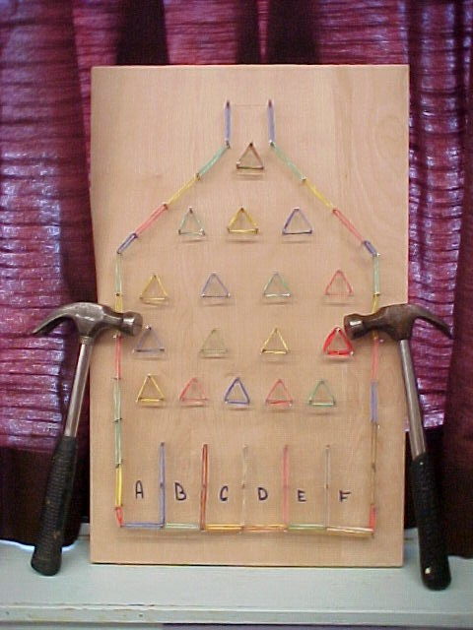
FOLK'S / GUARDIAN'S SIGNATURE ______________________ Beginning: Read over & get signed.
BUDDY CHECK SIGNATURE _____________________After: Buddy will suggest improvements.
Assigned: __________________________ Due Date: ______________________
SUGGESTIONS: Type it out. Include Computerized Graph (Excel).
EVALUATION Name: _____________________________
Homeroom: 7-1 7-2 7-3

CATEGORY | Level 1  Completed with limited understanding | Level 2  Completed with some degree of effectiveness | Level 3  Completed with considerable effectiveness | Level 4  Completed with a high degree of effectiveness
Knowledge & Understanding
- Discussion Questions
Thinking / Design
- Accurate Technical Design
- Effective design / product?
- Pleasing to the eye?
- Safe? Sturdy?
- Stable / Symmetrical?
Communication
- Math literacy
- Vocabulary
- Bar Graph (pencil, proper paper, titles, colour)
- Tally Chart / Frequency Chart
Application
- Applies knowledge/skills to the real world.
- Is it safe / useful for the public to use?
- Use of time / Safe with tools?
- Completeness? / Timeliness?
- Tidiness? / Independence?
Overall Mark:
Include this rubric with your write-up (last page!)

