p. 372 in the text (**REMEMBER:** THE DC {**DOUBLE CHECK**} substitute the answer back into the balanced equation!

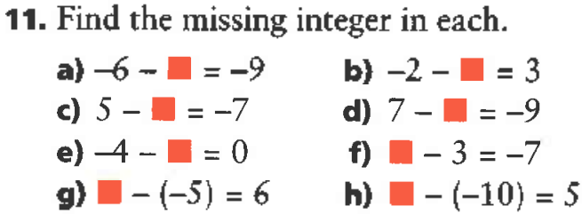

1. -6 – x = -9 **/** -6 + (-x) = -9

-6 – x + x = -9 + x

-6 = -9 + x

-6 + 9 = -9 + x + 9

3 = x

1. -2 – x = 3 **/** -2 + (-x) = 3

-2 - x + x = 3 + x

-2 = 3 + x

-2 – 3 = 3 + x – 3

-2 + (-3) = x

-5 = x

1. 5 – x = -7 **/** 5 +(-x) = -7

5 - x + x = -7 + x

5 = -7 + x

5 + 7 = -7 + x +7

12 = x

1. 7 – x = -9 **/** 7 – x = -9

7 – x + x = -9 + x 7 – x – 7 = -9 - 7

7 = -9 + x -x = -9 + (-7)

7 + 9 = -9 + x + 9 -x = -16

16 = x - x / -1 = -16 / -1

x = 16

1. -4 – x = 0 **/** -4 + (-x) = 0

-4 –x + x = 0 + x

-4 = x

1. x – 3 = -7 **/** x + (-3) = -7

x – 3 + 3 = -7 + 3

x = -4

1. x – (-5) = 6

x + 5 = 6

x + 5 – 5 = 6 – 5

x = 1

1. x – (-10) = 5

x + 10 = 5

x +10 – 10 = 5 – 10

x = -5