Name:

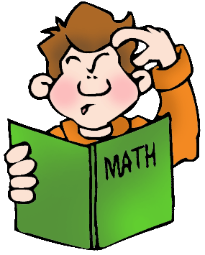 | Multiplication Table | 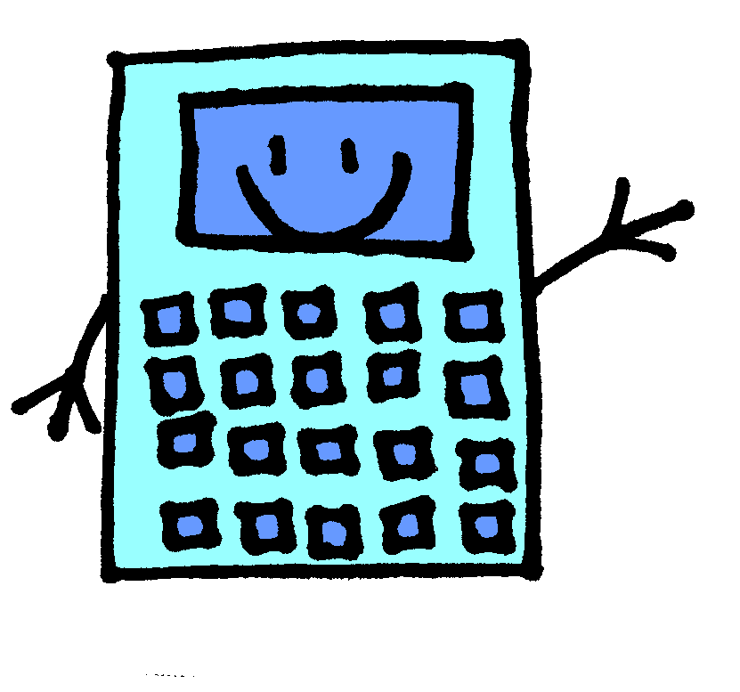

X | 1 | 2 | 3 | 4 | 5 | 6 | 7 | 8 | 9 | 10 | 11 | 12
1
2
3
4
5
6
7
8
9
10
11
12

