**FINANCIAL LITERACY BLOOKET 3 – ANSWERS**

Question 1: A machine that allows bank customers to deposit or withdraw money without visiting their bank.



1. ATM
2. CashApp
3. A Wallet
4. Cash Register

Question 2: The current amount of money in an account.



1. Deposit
2. Cheque
3. Savings Account
4. Balance

Question 3: A business that offers money-related services to its customers.



1. Bank
2. Identity Theft
3. Credit Union
4. Payday Loans

Question 4: Which is NOT a service offered by banks?

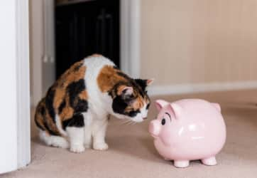

1. Savings Accounts
2. Loans
3. Chequing Accounts
4. Cryptocurrency

Question 5: A company that sells goods and services.



1. Credit Union
2. Bank
3. Business
4. Identity Theft

Question 6: A group of people chosen to manage or direct a business or organization.



1. ATM
2. Board of Directors
3. Financial Institution
4. Credit Union

Question 7: An investment that earns a set interest rate over a specific period of time.



1. Mutual Fund
2. Stocks
3. Guaranteed Investment Certificate (GIC)
4. Credit Union

Question 8: A written order to a bank to pay a certain amount of money from a chequing account to another person or business.



1. Loan
2. Cheque
3. Pay Stub
4. Savings Account

Question 9: A bank account used to pay bills and access funds using cheques and debit cards.

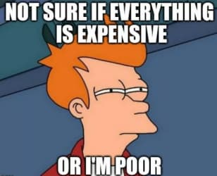

1. Chequing Account
2. Credit Union
3. Interest
4. Savings Account

Question 10: A card that allows the holder to buy goods and services by taking out a bank loan.



1. Debit Card
2. Credit Card
3. Gift Card
4. Rich Minion

Question 11: A bank account used to pay bills and access funds using cheques and debit cards.



1. Chequing Account
2. Savings Account
3. Car Loan
4. Farmer Brown’s

Question 12: A financial institution owned by its members that provides the same services as a bank.



1. Bank
2. Credit Union
3. Loan
4. Business

Question 13: A system that guides how money is earned and used in society.

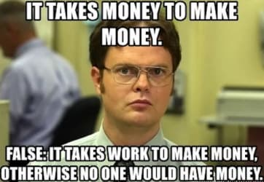

1. Economy
2. Capitalism
3. Democracy
4. Currency

Question 14: Payments made online or using an app.



1. Loan
2. Electronic Payment
3. Transaction
4. E-Receipt

Question 15: A business that provides money-related services.

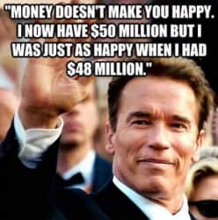

1. Financial Institution
2. Online Banking
3. Cryptocurrency
4. Cheque into Cash

Question 16: Money borrowed that must be repaid, usually with interest.



1. Loan
2. Deposit
3. Transfer
4. Withdraw

Question 17: A service that allows customers to perform banking activities using the internet.



1. Mr. Fitch’s Gimme-Gimme cash app
2. Online Banking
3. Deposit
4. Transfer

Question 18: A bank safe where documents, jewelry, or other valuables are kept.

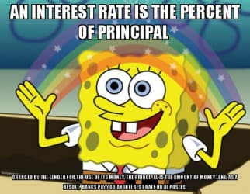

1. Chequing Account
2. Safe Deposit Box
3. Financial Institution
4. Mr. Fitch’s Room

Question 19: An account that usually earns interest and is often used to hold money that is not needed right away.

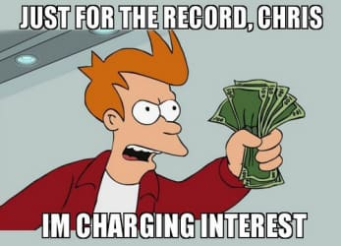

1. Chequing Account
2. Savings Account
3. Stock Market
4. Loan Payment

Question 20: A business agreement or exchange.



1. Contract
2. Stock Market
3. Transaction
4. Deposit

Question 21: The person responsible for a business's finances.

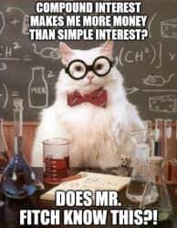

1. Bank teller
2. Chief Executive Officer (CEO)
3. Chief Financial Officer (CFO)
4. D. L. Fitch – Genius Extraordinaire

Question 22: A cheque that is written for more than the amount of money in a chequing account.

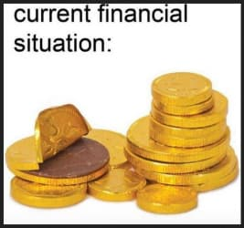

1. Deposit
2. Transaction
3. Overdraw
4. Bounced Cheque

Question 23: An electronic transfer of money from one account to another; often used by employers to pay employees.

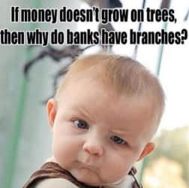

1. Deposit
2. Direct Deposit
3. Paystub
4. Transfer

Question 24: What is the crime of stealing someone else's personal or financial information for your own use?



1. Identity Theft
2. Transaction
3. Cryptocurrency
4. Bounced Cheque

Question 25: A number required when a person uses a debit card; it ensures others can't access the bank account.



1. Password
2. Birthday
3. PIN (Personal Identification Number)
4. Account Number

Question 26: To write a signature on the back of a cheque.



1. Autograph
2. Endorse
3. Signature
4. Name

Question 27: The money people earn for their work.



1. Paycheque
2. Transfer
3. Income
4. Taxes

Question 28: A cheque received for work completed.



1. Paycheque
2. Paystub
3. Personal Cheque
4. Income

Question 29: A cheque written from a personal chequing account.



1. Income
2. Paycheque
3. Net Deposit
4. Personal Cheque

Question 30: The amount of money placed into an account after all deductions, such as cash back and taxes are made.

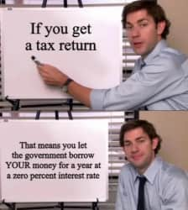

1. Gross Deposit
2. Net Deposit
3. Interest
4. Cashier’s Cheque

Question 31: A fee received or paid for the use of money.



1. Interest
2. Accrue
3. Paystub
4. Taxes

Question 32: To have money gain in increments, usually at a set rate.



1. Interest
2. Taxes
3. Accrue
4. PIN

Question 33: A card that is purchased for a certain amount (and sometimes, a certain store), and then used like cash.



1. Credit Card
2. Debit Card
3. Gift Card
4. Loan

Question 34: A card that allows customers to electronically and immediately withdraw funds from their accounts, either in cash or to purchase goods or services.



1. Debit Card
2. Gift Card
3. Credit Card
4. Loan

Question 35: A card that allows the holder to buy goods and services by taking out a bank loan.



1. Gift Card
2. Debit Card
3. Credit Card
4. Loan

Question 36: A card that allows you to spend only the amount you have pre-deposited.

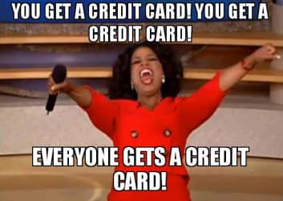

1. Loan
2. Credit Card
3. Debit Card
4. Prepaid Card

Question 37: The current amount of money in an account.



1. Deposit
2. Cheque
3. Savings Account
4. Balance