**FINANCIAL LITERACY BLOOKET 1 – ANSWERS**

Question 1: When you use a credit card you are really taking out a loan.

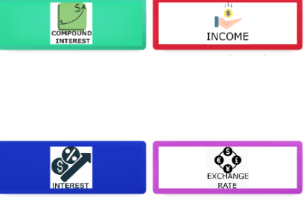

1. True
2. False
3. No if you pay it off each month.
4. Only is the card is NOT from your financial institution.

Question 2: Interest that's calculated based off of the original sum plus any value previously gained.



1. Sales Tax
2. Simple Interest
3. Wages
4. Compound Interest

Question 3: Money received for work or through investments. 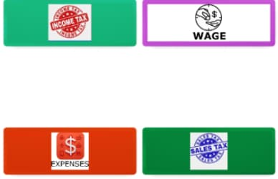

1. Income
2. Wages
3. Fee
4. Sales Tax

Question 4: A type of tax based upon your earnings/salary. 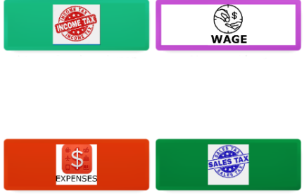

1. Sales Tax
2. Income Tax
3. Windfall Tax
4. Property Tax

Question 5: Money paid per hour of work.



1. Debt
2. Income
3. Wage
4. Salary

Question 6: A loan used to buy a home or land.

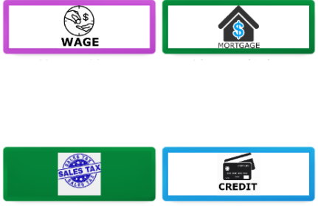

1. Sales Tax
2. Rent
3. Income Tax
4. Mortgage

Question 7: Money that is owed or due.

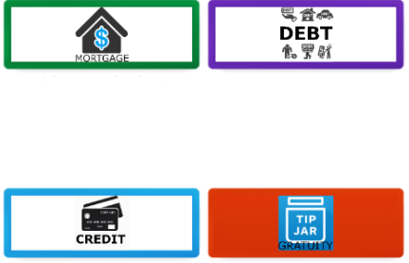

1. Debt
2. Simple Interest
3. Compound Interest
4. Taxes

Question 8: Money that is paid to an employee (annual pay).

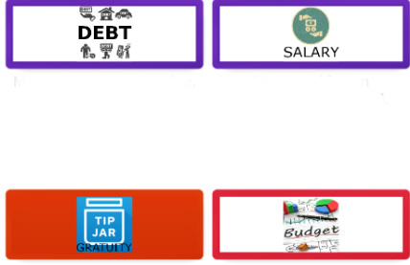

1. Income Tax
2. Salary
3. Fee
4. Wages

Question 9: Money paid regularly at a particular rate.

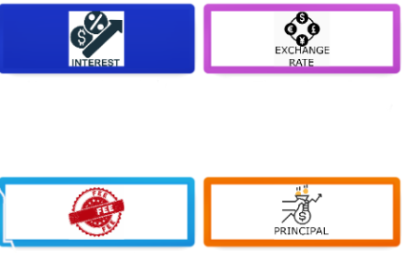

1. Wage
2. Fee
3. Sales Tax
4. Interest

Question 10:



1. Exchange Rate
2. Wages
3. Sales Tax
4. Compound Interest

Question 11: Money spent on necessities.

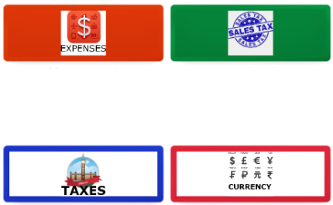

1. Fees
2. Taxes
3. Wages
4. Expenses

Question 12: A tax by the government on the sale of goods and services.



1. Income Tax
2. Capital Gains Tax
3. Sales Tax
4. Inheritance Tax

Question 13: The trust between a lender and a borrower.

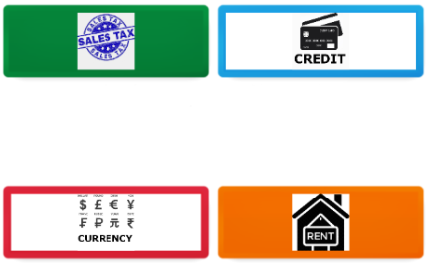

1. Credit
2. Exchange Rate
3. Loan
4. Compound Interest

Question 14: A tip given on top of the original fee.

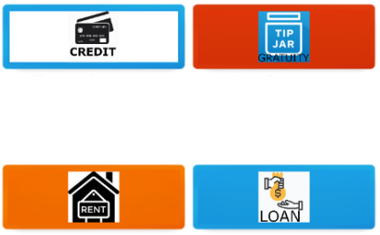

1. Sales Tax
2. Gratuity
3. Simple Interest
4. Debt

Question 15: A plan to balance income and expenses.

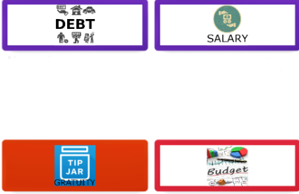

1. Principal
2. Mortgage
3. Budget
4. Gratuity

Question 16: A payment made to someone for a service.



1. Income Tax
2. Wage
3. Salary
4. Fee

Question 17: The original sum of money borrowed or invested.



1. Principal
2. Fee
3. Simple Interest
4. Sales Tax

Question 18: A financial charge that funds government spending.



1. Gratuity
2. Wages
3. Credit
4. Taxes

Question 19: A system of money used by a country.



1. Credit
2. Currency
3. Wage
4. Principal

Question 20: A regular payment to a landlord for the use of property or land. 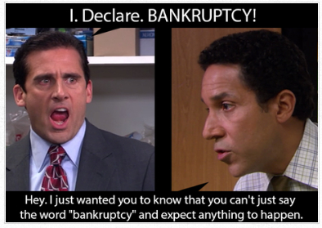

1. Simple Interest
2. Mortgage
3. Rent
4. Compound Interest

Question 21: Money that is borrowed that you pay back with interest.



1. Taxes
2. Expenses
3. Simple Interest
4. Loan