**Sales & Comparing Prices 2.0**

1. Write a question that represents the following equations

[(20x0.75)+(30-8)+(45x0.8)+12+(1200x0.5)] x 1.13 =

**Come back and do these if you make it through the other questions. Skip them for now**

[(300x0.65)+(400x0.8)+(23x0.2)+(32x0.55)+(100x0.6)] x 1.11 =

[(190x0.35)+(390x0.45)+(65-30)+(600x0.4)+25+(25x0.9)] x 1.13 =

[(12x0.1)+(420x0.35)+(75-20)+(800x0.55)+(35x0.95)] x 1.05 =

1. Using the skills you learned in Grade 7 Financial Literacy, you tally the price of your cart before being rung out at $30.89 including tax but the cashier comes up with $29.40 (this includes tax). Turns out one of your items was 25% off. If you bought carrots for $4.99, apples for $6.69, lettuce for $2.49, peaches for $3.99, milk for $5.29 and eggs for $3.89, which item was on sale?
2. 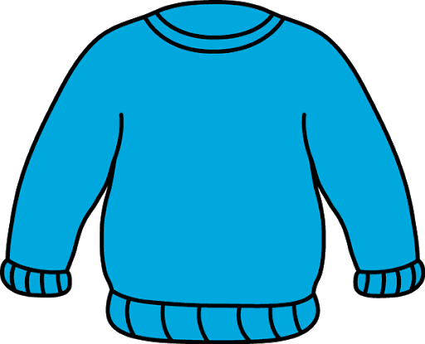Juan has 2 coupons for a new sweater. The first coupon will take $10 off of the sweater, the second will take 25% off. Which coupon should be applied before the other in order for Juan to save the most money? Does the order matter?
3. Coffee beans cost 5$ per pound but, to encourage bulk purchases, for every pound you buy the store will reduce the price of the next pound by 10%. How many pounds would you need to buy in order to pay less than $3/lb. for coffee beans?
4. Using the skills you learned in Grade 7 Financial Literacy, you tally the price of your cart before being rung out as $425.72 including tax but the cashier comes up with $401.08 (This includes tax). Turns out one of your items was 35% off. If you bought pillows for $44.79, drapes for $62.29, a duvet for $82.49, a painting for $37.99, a lamp for $55.29 and a chair for $93.89, which item was on sale?
5. You are running a lemonade stand and notice that for every $0.10 price reduction you gain 2 new sales a day. If you typically sell a glass for $4.50 to 20 customers each day, what is the optimal price of lemonade?

**Sales & Comparing Prices 2.0 - Answers**

1. Write a question that represents the following equations

[(20x0.75)+(30-8)+(45x0.8)+12+(1200x0.5)] x 1.13 =

E.g. It is time for a shopping trip. You go to the mall and buy a $20.00 shirt for 25% off, $30.00 pants for $8.00 off, $45.00 shoes for 20% off, $12.00 socks, and a flashy $1,200 watch for a whopping 50% off! How much did you spend on your shopping trip after tax?

**Come back and do these if you make it through the other questions. Skip them for now**

[(300x0.65)+(400x0.8)+(23x0.2)+(32x0.55)+(100x0.6)] x 1.11 =

[(190x0.35)+(390x0.45)+(65-30)+(600x0.4)+25+(25x0.9)] x 1.13 =

[(12x0.1)+(420x0.35)+(75-20)+(800x0.55)+(35x0.95)] x 1.05 =

2. Using the skills you learned in Grade 7 Financial Literacy, you tally the price of your cart before being rung out at $30.89 including tax but the cashier comes up with $29.40 (this includes tax). Turns out one of your items was 25% off. If you bought carrots for $4.99, apples for $6.69, lettuce for $2.49, peaches for $3.99, milk for $5.29 and eggs for $3.89, which item was on sale?

[$4.99 + $6.69 + $2.49 + $3.99 + $5.29(0.75) + $3.89] x 1.13 = $29.40

∴ The $5.29 milk was on sale.

1. Juan has 2 coupons for a new sweater. The first coupon will take $10 off of the sweater, the second will take 25% off. Which coupon should be applied before the other in order for Juan to save the most money? Does the order matter?

Use any dollar amount. E.g. $30.00

$10 off first:

$30.00 - $10.00 = $20.00

$20.00 x 0.75 = $15.00

25% off first:

$30.00 x 0.75 = $22.50

$22.50 - $10.00 = $12.50

∴ Juan should use the 25% off coupon before using the $10.00 off

coupon to save the most money. The order DOES matter – for any dollar amount, taking off 25% before taking off $10.00 always yields a bigger discount.

1. Coffee beans cost 5$ per pound but, to encourage bulk purchases, for every pound you buy the store will reduce the price of the next pound by 10%. How many pounds would you need to buy in order to pay less than $3/lb. for coffee beans?

1 pound: $5.00

2 pounds: $10.00 x 0.90 = $9.00

3 pounds: $9.00 x 0.90 = $8.10

$8.10/3 pounds = $2.70/pound

∴ In order to pay less than $3/lb. for coffee beans, you would have to buy three pounds worth.

1. Using the skills you learned in Grade 7 Financial Literacy, you tally the price of your cart before being rung out as $425.72 including tax but the cashier comes up with $401.08 (This includes tax). Turns out one of your items was 35% off. If you bought pillows for $44.79, drapes for $62.29, a duvet for $82.49, a painting for $37.99, a lamp for $55.29 and a chair for $93.89, which item was on sale?

[$44.79 + $62.29(0.65) + $82.49 + $37.99 + $55.29 + $93.89] x 1.13 = $401.08

∴ The $62.29 drapes were on sale.

1. You are running a lemonade stand and notice that for every $0.10 price reduction you gain 2 new sales a day. If you typically sell a glass for $4.50 to 20 customers each day, what is the optimal price of lemonade?

As you reduce price by $0.10, add 2 more customers and multiply to find total sales.

$4.50 x 20 = $90.00

$4.00 x 30 = $96.80

$3.50 x 40 = $140.00

$3.00 x 50 = $150.00 🡪 peak sales fall somewhere between here…

$2.50 x 60 = $150.00 🡪 …and here

$2.00 x 70 = $140.00

$2.90 x 52 = $150.80

$2.80 x 54 = $151.20

$2.70 x 56 = $151.20

$2.60 x 58 = $150.80

∴ The optimal price of lemonade is either $2.80 or $2.70.