**Sales & Comparing Prices**

1. A pair of slippers, originally priced at $20, have gone on sale for 25% off. What is their price before taxes now?

1. The florist is having a sale, $10 off all tulips! The tulips Bernardo wants to buy for his mother originally cost $35, how much will they cost now?

1. A sweater that Ryan likes is on sale for 25% off of its retail price of $70. How much will Ryan pay for the sweater?

1. Coffee is 30% off on Tuesdays. If a cup of coffee normally costs $5, how much will it cost on a Tuesday?

1. Darnell wants to buy some flour, he can buy the $20 flour that is now 20% off or the $15 flour that is not on sale. Which flour should Darnell buy?
2. Lysha takes the bus every weekday to work for the full year. A bus ticket costs $3.60 **each way**, or she could buy a monthly bus pass for $122.50. Is the bus pass a worthwhile purchase for Lysha? (Assume that there are 4 weeks in a month and Lysha doesn’t work weekends)

1. Rachel is deciding between two products each $30 but one is $10 off, the other is 40% off. Which should she buy?
2. Ahmed waited for DVDs to go on sale before buying his two favourites. The DVD’s were originally priced $22 each and are now on sale for 30% off. How much will Ahmed spend on DVDs?
3. Taylor is looking to buy new rock climbing shoes, there are 2 pairs of shoes for sale each for $65. One pair is 30% off and the other is having a buy one get one free sale. What would she have to pay for each pair? Which should she buy?

1. Sarah needs to buy 2 containers of laundry detergent. The original cost was the same at all stores: $15.00. Each store is having a sale. Jerry’s Grocer is having a 30% off sale, Zara’s Corner store is having a Buy One Get One Free sale and Fatima’s Convenience Store is having a $5 off sale. Who should Sarah buy from?
2. Zendaya wants to buy a pair of shoes that cost $80, the shoes are 35% off. How much will Zendaya SAVE on these shoes?

**Sales & Comparing Prices - ANSWERS**

1. A pair of slippers, originally priced at $20, have gone on sale for 25% off. What is their price before taxes now?



$20.00 x 0.75 = $15.00

∴ The price of the slippers before tax is $15.00.

1. The florist is having a sale, $10 off all tulips! The tulips Bernardo wants to buy for his mother originally cost $35, how much will they cost now?



$35.00 - $10.00 = $25.00

$25.00 x 1.13 = $28.25

∴ The price of the tulips will be $28.25.

1. A sweater that Ryan likes is on sale for 25% off of its retail price of $70. How much will Ryan pay for the sweater?

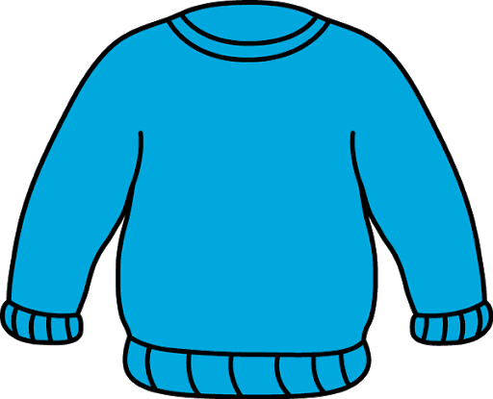

$70.00 x 0.75 = $52.50

$52.50 x 1.13 = $59.33

∴ The price of the sweater will be $59.33.

1. Coffee is 30% off on Tuesdays. If a cup of coffee normally costs $5, how much will it cost on a Tuesday?



$5.00 x 0.70 = $3.50

$3.50 x 1.13 = $3.96

∴ The price of the coffee on Tuesday will be $3.96.

1. Darnell wants to buy some flour, he can buy the $20 flour that is now 20% off or the $15 flour that is not on sale. Which flour should Darnell buy?

$20.00 x 0.80 = $16.00

∴ Darnell should buy the $15.00 flour because the $20.00 flour is only

$16.00 on sale.

1. Lysha takes the bus every weekday to work for the full year. A bus ticket costs $3.60 **each way**, or she could buy a monthly bus pass for $122.50. Is the bus pass a worthwhile purchase for Lysha? (Assume that there are 4 weeks in a month and Lysha doesn’t work weekends)



Every weekday: 5 days a week

5 x 4 weeks in a month = 20 workdays in a month

20 x 2 bus tickets a day = 40 bus tickets a month

$3.60 x 1.13 = $4.07 for a bus ticket

$4.07 x 40 = $162.8 a month

∴ Yes, the $122.50 bus pass is worthwhile for Lysha. Otherwise, she will be paying $162.80 a month for bus tickets.

1. Rachel is deciding between two products each $30 but one is $10 off, the other is 40% off. Which should she buy?

$30.00 - $10.00 = $20.00

$30.00 x 0.60 = $18.00

∴ Rachel should buy the product that is 40% off.

1. Ahmed waited for DVDs to go on sale before buying his two favourites. The DVD’s were originally priced $22 each and are now on sale for 30% off. How much will Ahmed spend on DVDs?

$22.00 x 0.70 = $15.40

$15.40 x 2 = $30.80

$30.80 x 1.13 = $34.80

∴ Ahmed will spend $34.80 on two DVDs.

1. Taylor is looking to buy new rock climbing shoes, there are 2 pairs of shoes for sale each for $65. One pair is 30% off and the other is having a buy one get one free sale. What would she have to pay for each pair? Which should she buy?



$65.00 x 0.70 = $45.50 for a pair

$65.00 for two pairs = $32.50 for a pair

∴ Taylor will spend $45.50 a pair for the 30% sale and $32.50 a pair for the buy one get one free sale. Taylor should buy the shoes on the buy one get one free sale.

1. Sarah needs to buy 2 containers of laundry detergent. The original cost was the same at all stores: $15.00. Each store is having a sale. Jerry’s Grocer is having a 30% off sale, Zara’s Corner store is having a Buy One Get One Free sale and Fatima’s Convenience Store is having a $5 off sale. Who should Sarah buy from?

$15.00 x 2 containers = $30.00

**Jerry:** $30.00 x 0.70 = $21.00 for two containers

**Zara:** Buy one get one free = $15.00 for two containers

**Fatima:** $10.00 off $30.00 = $20.00 for two containers

∴ Sarah should buy two containers of detergent from Zara’s corner store.

1. Zendaya wants to buy a pair of shoes that cost $80, the shoes are 35% off. How much will Zendaya SAVE on these shoes?



$80.00 x 0.35 = $28.00

∴ Zendaya will save $28.00 on these shoes.