Find the **area of the shaded** regions.

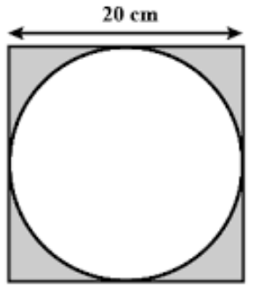

Area of Square = l x w

= 20 cm x 20 cm

= 400 $cm^{2}$

Area of circle = $πr^{2}$

= $3.14 x (10 c{m)}^{2}$

= 314.16 $cm^{2}$

Shaded Area = A square – A circle

= $400 cm^{2}- 314.16 cm^{2}$

= **85.84 $cm^{2}$**

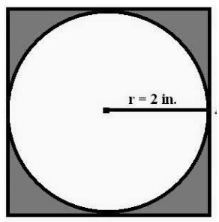Area of Square = l x w

= 4 in x 4 in

= 16 $in^{2}$

Area of circle = $πr^{2}$

= $3.14 x {\left(2 in\right)}^{2}$

= 12.56 $in^{2}$

Shaded Area = A square – A circle

= $16 in^{2}- 12.56 in^{2}$

= **3.44 $in^{2}$**

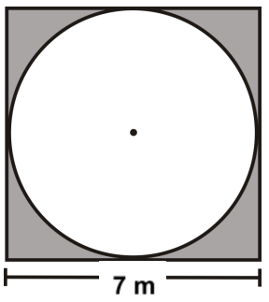 Area of Square = l x w

= 7 m x 7 m

= 49 $m^{2}$

Area of circle = $πr^{2}$

= $3.14 x (3.5 {m)}^{2}$

= 38.48 $m^{2}$

Shaded Area = A square – A circle

= $49 m^{2}- 38.48 m^{2}$

= **10.52 $m^{2}$**