**Radius & Diameter Practice**

1. For each of the following circles, determine the radius given the diameter:

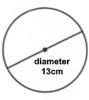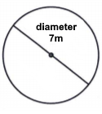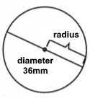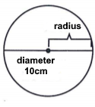

r =________ r =________ r =________ r =________

1. For each of the following circles, determine the diameter given the radius:

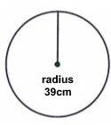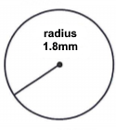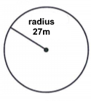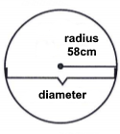

d =________ d =________ d =________ d =________

1. For each circle, draw and measure the radius and diameter. Label both of these on 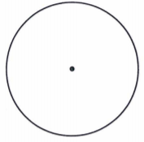the circle:





1. Fill in the missing radius or diameter for each circle in the table:

|  |  |  |  |  |  |  |  |  |  |  |
| --- | --- | --- | --- | --- | --- | --- | --- | --- | --- | --- |
| **radius** | 8cm |  | 2mm |  | 1.9m |  | 6.4m |  | 3.3cm | *r* cm |
| **diameter** |  | 6.4mm |  | 17m |  | 2.8cm |  | 31mm |  |  |

**Radius & Diameter Practice - Solutions**

1. For each of the following circles, determine the radius given the diameter:



r = **5cm**  r = **18mm** r = **3.5m** r = **6.5cm**

1. For each of the following circles, determine the diameter given the radius:



d =**116cm**  d = **54m**  d = **3.6mm**  d =**78cm**

1. For each circle, draw and measure the radius and diameter. Label both of these on the circle:





1. Fill in the missing radius or diameter for each circle in the table:

|  |  |  |  |  |  |  |  |  |  |  |
| --- | --- | --- | --- | --- | --- | --- | --- | --- | --- | --- |
| **radius** | 8cm | **3.2mm** | 2mm | **8.5m** | 1.9m | **1.4cm** | 6.4m | **15.5mm** | 3.3cm | *r* cm |
| **diameter** | **16cm** | 6.4mm | **4mm** | 17m | **3.8m** | 2.8cm | **12.8m** | 31mm | **6.6cm** | **2r cm** |