**ALGEBRA (EQUATIONS) – ANSWERS**

**Question 1:** 4x+7=35

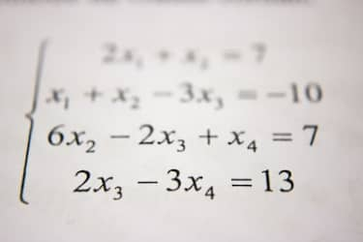

1. x=6
2. y=93
3. x=8
4. x=7

**Question 2:** 8s+9=33



1. s=28
2. s=33
3. s=4
4. s=3

**Question 3:** 8x+10=98

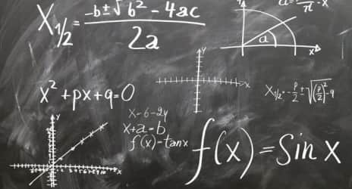

1. x=20
2. x=11
3. x=17
4. x=15

**Question 4:** 2x + 6 = 8



1. x=5
2. x=9
3. x=1
4. x=10

**Question 5:** What is the golden rule?



1. What you do to one side, you do to the other
2. Use inverse operations
3. Do not shout out during class
4. There is no rule

**Question 6:** 3x + 2 = 17

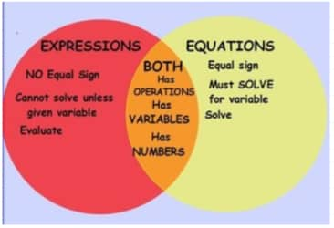

1. x=5
2. x= -11
3. x= -2
4. x= -6

**Question 7:** 3x - 4 = 11

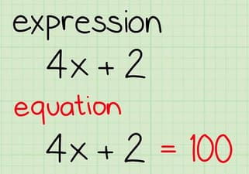

1. x=7
2. x=5
3. x=3
4. x=15

**Question 8:** 4x - 7 = 33

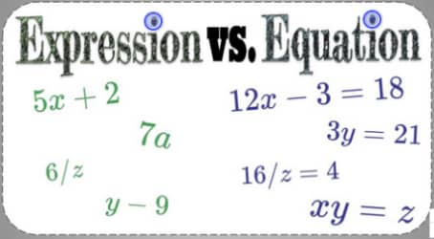

1. x=6.5
2. x=160
3. x=10
4. x=104

**Question 9:** 2a-5=27

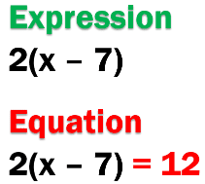

1. a=16
2. a=11
3. a=64
4. a=44

**Question 10:** 2a-5=27

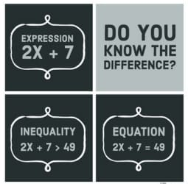

1. x=6.75
2. x=160
3. x=5
4. x=33

**Question 11:** 2a-5=27

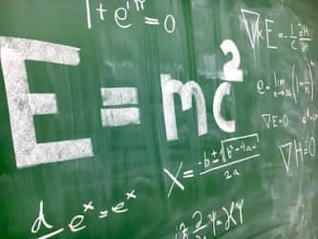

1. a=16
2. a=11
3. a=64
4. a=44

**Question 12:** 2m -4 = 12

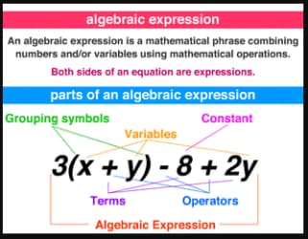

1. x=14
2. x=10
3. x=6
4. x=8

**Question 13:** 5w-10 = 15

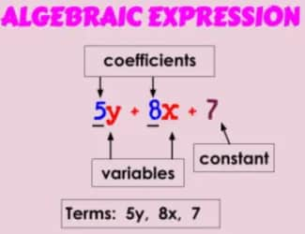

1. w=3
2. w=10
3. w=5
4. w=25

**Question 14:** 4x + 10 = 34

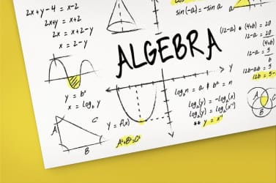

1. x=6
2. x=8
3. x=14
4. x=11

**Question 15:** 10x - 4 = 56

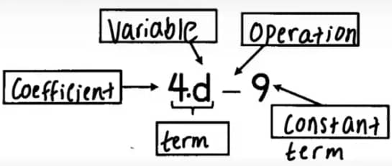

1. x=6
2. x=14
3. x=5.2
4. x=10

**Question 16:** 9x + 11 = 38



1. x=3
2. x=20
3. x=7
4. x=9

**Question 17:** 11x - 9 = 46

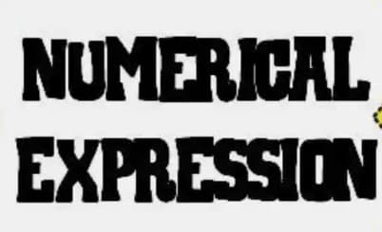

1. x=5
2. x=2
3. x=11
4. x=15

**Question 18:** 6x + 3 = 63

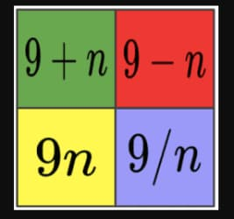

1. x=10
2. x=11
3. x=9
4. x=16

**Question 19:** 7x - 4 = 17



1. x=3
2. x=2
3. x=4
4. x=13

**Question 20:** 3x + 8 = 41

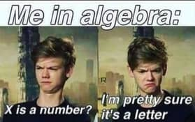

1. x=11
2. x=20
3. x=10
4. x=13

**Question 21:** 4x + 8 = 28

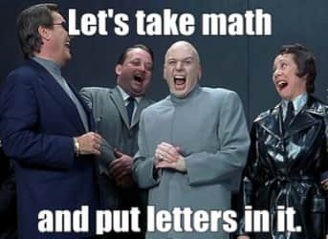

1. x=5
2. x=12
3. x=2
4. x=9

**Question 22:** 8x - 3 = 29



1. x=4
2. x=3
3. x=5
4. x=12

**Question 23:** 3x + 20 = 38

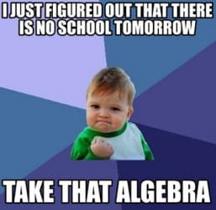

1. x=6
2. x=23
3. x=20
4. x=60

**Question 24:** x ÷ 10 + 3 = 4

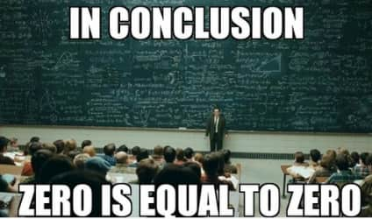

1. x=10
2. x=70
3. x=43
4. x=37

**Question 25:** -4x+7=15



1. x=4
2. x=2
3. x=-4
4. x=-2

**Question 26:** 3r+2r-r: Simplify the expression

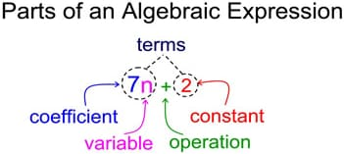

1. 4r
2. 5
3. 3r
4. 3

**Question 27:** If e= 9, what is 7+9e=

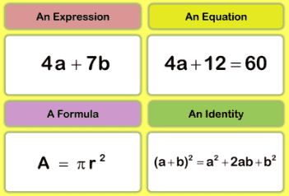

1. 84
2. 88
3. 81
4. 87

**Question 28:** 6a - 4 = 14 what is a?



1. 3
2. 6
3. 2
4. 5

**Question 29:** 16x-40=24



1. x=4
2. x=6
3. x=5
4. n=7

**Question 30:** 23x-12=34



1. x=4
2. x=2
3. x=8
4. x=12

**Question 31:** 3x-10=8



1. x=7
2. x=5
3. x=6
4. x=4

**Question 32:** 12x-9=51



1. x=8
2. x=3
3. x=6
4. x=5

**Question 33:** 52x-6=46



1. x=2
2. x=3
3. x=1
4. x=0

**Question 34:** 21+3x=27



1. x=1
2. x=2
3. x=3
4. x=4

**Question 35:** 18-6x=0



1. x=6
2. x=5
3. x=3
4. x=9

**Question 36:** Solve for X. 2X + 29 = 31



1. X=2
2. X=1
3. 2X=2
4. Y=1

**Question 37:** If X = 5, then what is 2X + 20 -3

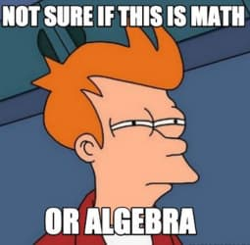

1. 30
2. 27
3. 37
4. 40

**Question 38:** 3x + 5 = 23



1. x=28/3
2. x=6
3. x=3
4. x=18

**Question 39:** 9x + 4 = 31



1. x=35
2. x=3
3. x=35/9
4. x=27

**Question 40:** 4 + 2x = 8



1. x=6
2. x=2
3. x=5
4. x=4

**Question 41:** 2x + 1 = 11



1. x=5
2. x=3
3. x=10
4. x=2

**Question 42:** 2x - 20 = 180



1. x=-80
2. x=80
3. x=-100
4. x=100

**Question 43:** 8x + 3 = 35



1. x=10
2. x=4
3. x=40
4. x=-4

**Question 44:** 5x - 5 = 25



1. x=6
2. x=18
3. x=4
4. Subtraction

**Question 45:** 4x + 7 = 39

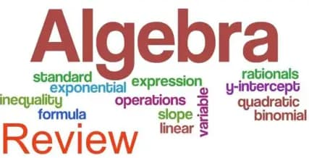

1. Subtraction
2. x=5
3. x=4
4. x=8

**Question 46:** 5 + 2w = 13



1. x=9
2. x=4
3. x=5
4. x=6

**Question 47:** 3f + 5 = 35



1. f=10
2. f=15
3. f=37
4. f=40/3

**Question 48:** 6d - 6 = 48



1. d=7
2. d=9
3. d=42
4. d=d-2

**Question 49:** 6x + 6 = 48



1. x=7
2. x=8
3. x=36
4. x=9

**Question 50:** 5c + 4 = 59

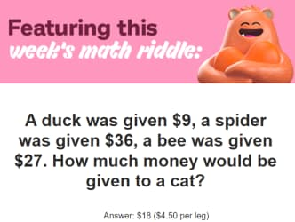

1. c=-11
2. c=50
3. c=12
4. c=11

**Question 51:** 3b + 6 = 42



1. b=11
2. b=-16
3. b=12
4. b=16

**Question 52:** 11=3x+5



1. x=1
2. x=4
3. x=6
4. x=2

**Question 53:** 2x-4=6



1. x=5
2. x=3
3. x=-5
4. x=2

**Question 54:** 3+9x = 21



1. x=3
2. x=2
3. x=-2
4. x=6

**Question 55:** 3g + 12 = 33



1. g=0
2. g=9
3. g=4
4. g=7

**Question 56:** 4c - 16 = 12



1. c=5
2. c=2
3. c=7
4. c=8

**Question 57:** Simplify 2p + 4 + 6p + 1



1. 8p+5
2. 6p+7p
3. 12p
4. None

**Question 58:** Simplify: 4x + 7 - x + 5



1. 16
2. 4x+12
3. 11x+4
4. 3x+12

**Question 59:** Simplify 5d + 10d + 3 + 5



1. 15d+8
2. 23d
3. 50d+15
4. None

**Question 60:** Simplify 2p + 4 + 6p + 1



1. 8p+5
2. 6p+7p
3. 13p
4. None

**Question 61:** Simplify the expression: 10x+6x



1. 16xx
2. 4x
3. 16x ²
4. 16x

**Question 62:** Simplify the expression: 12y-3y



1. 9y
2. 15yy
3. 15y
4. 9y²

**Question 63:** Simplify the expression: 5u+7+8u+8



1. 31u
2. 15u+13
3. 13u+15
4. 16u+8

**Question 64:** Simplify: 10y - 7 + 2y



1. 3y+2
2. 7y-10
3. 12y-7
4. 3x-7

**Question 65:** Simplify the following expression: -2x + 5x - 9 + 10



1. 7x+19
2. =7x-1
3. 3x+1
4. 3x-1