**PROBABILITY, PART II – ANSWERS**

Question 1: If you pick a marble from this jar at random, how many possible outcomes are there?

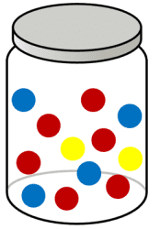

1. 3
2. 5
3. 10
4. 12

Question 2: You are hoping to pick a red marble from this jar. How many favourable outcomes are there?



1. 4
2. 5
3. 6
4. 12

Question 3: What is the probability you pick a red marble from this jar?



1. 12/6
2. 1/2
3. 1/4
4. 1/3

Question 4: What is the probability that you spin a yellow?

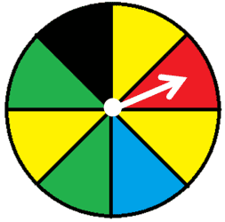

1. 1/2
2. 3/8
3. 1/3
4. 3/4

Question 5: What is the probability that you spin a green?



1. 1/4
2. 2/8
3. 3/4
4. 1/2

Question 6: What is the probability that you spin a black OR a red section?



1. 3/4
2. 3/8
3. 1/4
4. 1/2

Question 7: What is the correct equation to calculate the probability (P) of event A OR B?

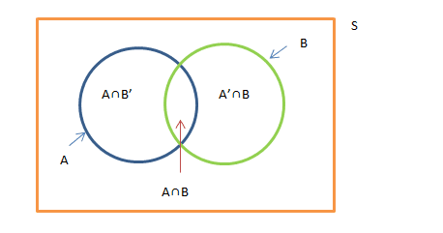

1. P(A) x P(B)
2. P(A) - P(B)
3. P(A) + P(B)
4. P(A) ÷ P(B)

Question 8: What is the correct equation to calculate the probability (P) of event A AND B?



1. P(A) x P(B)
2. P(A) - P(B)
3. P(A) + P(B)
4. P(A) ÷ P(B)

Question 9: THEORETICAL PROBABILITY is what is expected to happen in an event or experiment.

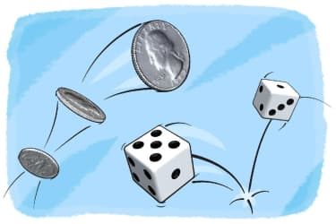

1. True
2. False

Question 10: EXPERIMENTAL PROBABILITY is what actually happens in an event or experiment.



1. True
2. False

Question 11: What is the correct equation to calculate theoretical probability?





Question 12: What is the correct equation to calculate experimental probability?





Question 13: What is the probability of rolling a 4 on this die?

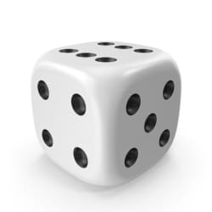

1. 1/4
2. 1/2
3. 4/6
4. 1/6

Question 14: What is the probability of rolling a 1 OR a 2 on this die?



1. 1/6
2. 1/2
3. 1
4. 1/3

Question 15: What is the probability of rolling >2 on this die?



1. 3/6
2. 1/3
3. 1/2
4. 2/3

Question 16: What is the probability of rolling ≥2 on this die?



1. 2/6
2. 3/6
3. 4/6
4. 5/6

Question 17: What is the probability of rolling ≤3 on this die?



1. 2/6
2. 5/6
3. 1/2
4. 4/6

Question 18: What is the probability of rolling <6 on this die?



1. 4/6
2. 5/6
3. 1
4. 0

Question 19: What is the probability of rolling a sum of 4 with two dice?

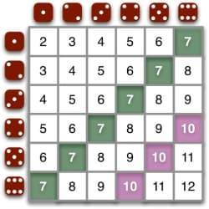

1. 4/36
2. 1/36
3. 1/12
4. 1/2

Question 20: What is the probability of rolling a sum of <5 with two dice?



1. 1/6
2. 5/36
3. 1/36
4. 1/2

Question 21: What is the probability of rolling a sum of ≥2 with two dice?



1. 2/36
2. 1
3. 1/36
4. 1/2

Question 22: What is the probability of rolling a sum of >2 with two dice?



1. 1/36
2. 2/36
3. 1/2
4. 35/36

Question 23: What is the probability of flipping two coins and both coins landing on heads?

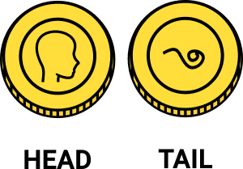

1. 1/2
2. 0
3. 1/4
4. 1

Question 24: What is the probability of flipping two coins and one coin lands on heads and one on tails?



1. 1/2
2. 0
3. 1/4
4. 1

Question 25: Based on this diagram, what is the probability of spinning 2 blues?

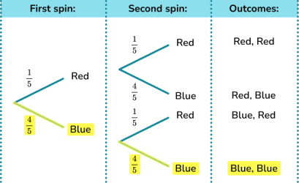

1. 1/25
2. 16/25
3. 2/25
4. 2/5

Question 26: Based on this diagram, what is the probability of spinning 2 reds?



1. 1/25
2. 16/25
3. 2/25
4. 2/5

Question 27: Based on this diagram, what is the probability of spinning a red then a blue?



1. 1/25
2. 1/5
3. 4/25
4. 2/5

Question 28: Based on this diagram, what is the probability of spinning a blue then a red?



1. 1/25
2. 1/5
3. 4/25
4. 2/5

Question 29: What is the probability of any of these outcomes?

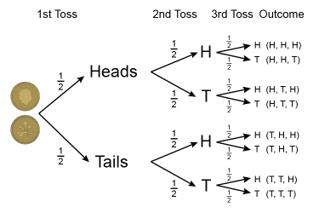

1. 1/2
2. 1/8
3. 1/4
4. 1

Question 30: The law of large numbers states that...

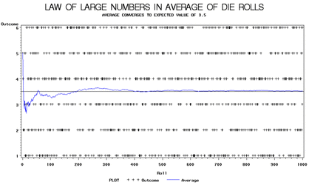

1. Theoretical probability will always be larger than experimental probability
2. The less trials performed, the closer you will be to the theoretical probability
3. Experimental probability will always be larger than theoretical probability
4. The more trials performed, the closer you will get to the theoretical probability

Question 31: The more you flip a coin, the ________ you will get to the theoretical probability.

1. Closer
2. Farther

Question 32: The less you flip a coin, the ________ you will be to the theoretical probability.

1. Closer
2. Farther

Question 33: You are more likely to flip HTHT than HHHH.

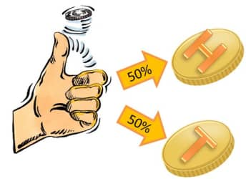

1. True
2. False

Question 34: You are more likely to flip HTHT than TTHH.



1. True
2. False

Question 35: On this die, what is the P(>14)?

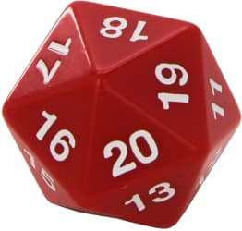

1. 6/20
2. 13/20
3. 14/20
4. 15/20

Question 36: On this die, what is the P(<3)?



1. 0.01
2. 0.1
3. 0.3
4. 0.2

Question 37: On this die, what is the P(5, 10, or 15)?



1. 15%
2. 25%
3. 50%
4. 75%

Question 38: On a twenty-sided die, how many times would you expect to roll a number greater than 16 out of 31 rolls?



1. ~0.2
2. ~12
3. ~6
4. ~27

Question 39: What is the probability that a square has 4 sides?

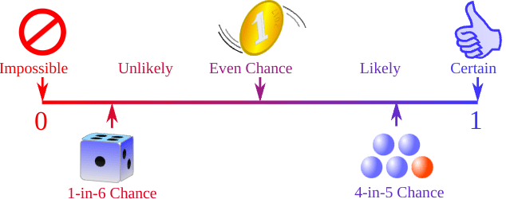

1. Impossible
2. Unlikely
3. Likely
4. Certain

Question 40: What is the probability that the Rideau Canal will be frozen by February?



1. Impossible
2. Unlikely
3. Likely
4. Certain

Question 41: What is the probability that Mr. Fitch will be away tomorrow?



1. Impossible
2. Unlikely
3. Likely
4. Certain

Question 42: What is the probability that you will roll a sum of 1 with two dice?



1. Impossible
2. Unlikely
3. Likely
4. Certain

Question 43: If Mr. K spins the spinner slowly to try to land on a certain colour, his result will be:

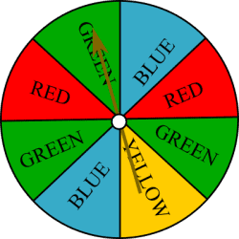

1. Random
2. Biased
3. Unfavourable
4. Certain

Question 44: If Mr. K spins the spinner without looking and without trying to land on a specific number, his result will be:



1. Random
2. Biased
3. Unfavourable
4. Certain

Question 45: An independent event is one in which the result of the first event DOES NOT affect the result of the second event.

1. True
2. False

Question 46: A dependent event is one in which the result of the first event DOES affect the result of the second event.

1. True
2. False

Question 47: An example of a dependent event:

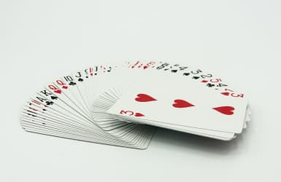

1. Pulling a King from a card deck and replacing it, then pulling a Queen
2. Pulling a King from a card deck, then without replacing it, pulling a Queen

Question 48: An example of an independent event:



1. Spinning a yellow, then a green, on this spinner
2. Spinning a yellow, cutting it out, then spinning a green on this spinner

Question 49: What is a simple event?

1. An event that has multiple outcomes
2. An event that has a single outcome
3. An event that gives you the same outcome every time
4. An event that gives you the favourable outcome every time

Question 50: What is an example of a simple event?

1. Getting a 3 when you roll a die
2. Getting a 3 and then a 4 when you roll a die
3. Pulling a King twice from a deck of cards
4. Pulling a King then a Queen from a deck of cards

Question 51: When flipping a coin, what is the P(H then H)?



1. 1/2
2. 1/4
3. 0
4. 1

Question 52: You roll a 6-sided die then flip a coin. What is the P(3 then tails)?

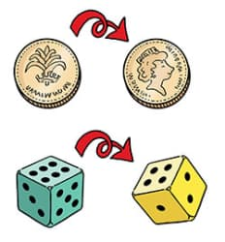

1. 1/12
2. 1/6
3. 1/2
4. 0

Question 53: In probability, bias is...

1. The likelihood that an event is random
2. The outcome you get from a large sample size
3. An inaccurate representation of something
4. The likelihood of a simple event

Question 54: What is compound probability?

1. Another term for theoretical probability
2. What we expect to happen in an experiment
3. What actually happens in an experiment
4. The likelihood of a combination of events occurring

Question 55:

What is the probability of picking red, replacing it, then picking blue?

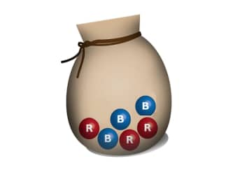

1. 1/2
2. 1/4
3. 1/6
4. 0

Question 56: What is the probability of picking red, NOT replacing it, then picking blue?



1. 3/5
2. 2/10
3. 1/2
4. 3/10