**FRACTIONS – ANSWERS**

Question 1: 1/6 x 2/3 =



1. 2/18
2. 3/9
3. 1/3
4. 1/9

Question 2: What is 2 ÷ ³/₅ as a mixed number?

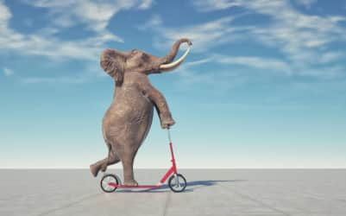

1. 10/3
2. 1 1/5
3. 3 1/3
4. 6/5

Question 3: Write 37/7 as a mixed number.

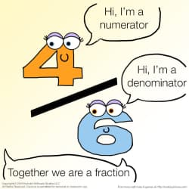

1. 30/7
2. 5 2/7
3. 2/7
4. 3 7/7

Question 4: Write 2 4/9 as an improper fraction

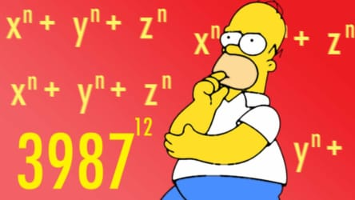

1. 18/9
2. 22/9
3. 24/9
4. 1 13/9

Question 5: Which fraction is equivalent to 2/3?

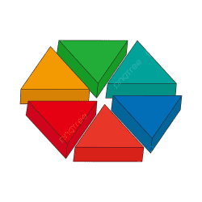

1. 6/9
2. 3/4
3. 5/6
4. 4/10

Question 6: Which fraction is NOT equivalent to 2/4?

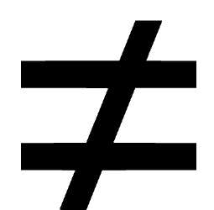

1. 1/2
2. 3/6
3. 6/10
4. 4/8

Question 7: 5 x 4/5



1. 1
2. 2
3. 3
4. 4

Question 8: 9 ÷ 21



1. 9/21
2. 3/7
3. 3
4. 4

Question 9: Simplify 10/10



1. 1/1
2. 2
3. 1
4. 5

Question 10: What fraction is shown? (Note: Golden Rule)

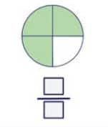

1. 3/4
2. 2/4
3. 1/3
4. 3/2

Question 11: What fraction is shown? (Note: Golden Rule)

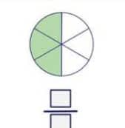

1. 3/6
2. 1/2
3. 3/4
4. 2/6

Question 12: What fraction is shown? (Note: Golden Rule)

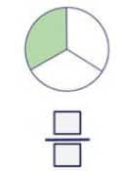

1. 1/3
2. 2/3
3. 3/3
4. 4/4

Question 13: What is the simplified version of 6/18?

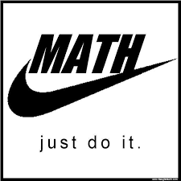

1. 3/9
2. 2/3
3. 1/6
4. 1/3

Question 14: 1/2 + 3/2

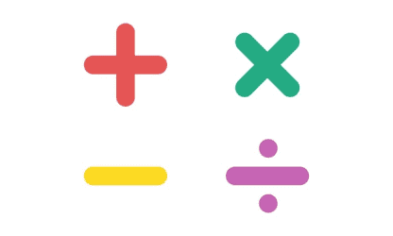

1. 1
2. 2
3. 3
4. 4

Question 15: 1/2 + 3/4

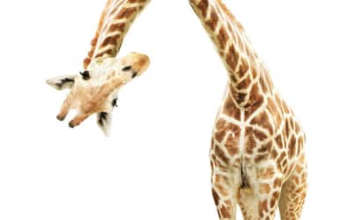

1. 1
2. 3/4
3. 5/4
4. 4/6

Question 16: 3/4 - 2/4

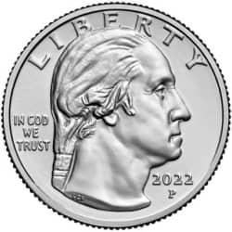

1. 2/3
2. 1/4
3. 2/4
4. 1/2

Question 17: 1/2 – 1/4

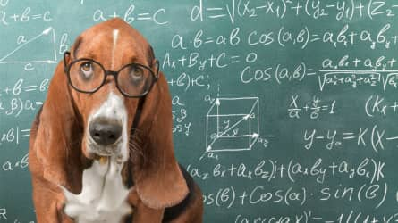

1. 1/4
2. 2/4
3. 1/2
4. 3/4

Question 18: What is the fraction shown? (Note: Golden Rule)

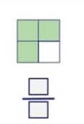

1. 1/4
2. 2/4
3. 1/2
4. 3/4

Question 19: What fraction is represented in the image? (Note: Golden Rule)

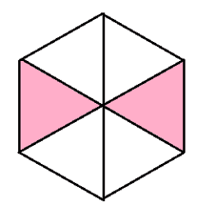

1. 6/2
2. 4/2
3. 1/3
4. 2/6

Question 20: What fraction is this? (Note: Golden Rule)

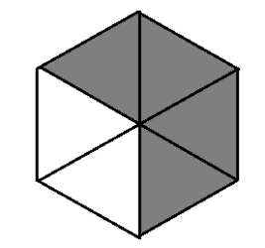

1. 4/6
2. 2/3
3. 3/6
4. 4/5

Question 21: What is the fraction shown? (Note: Golden Rule)

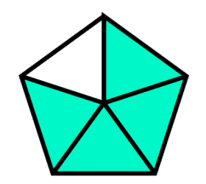

1. 1/5
2. 4/6
3. 4/5
4. 1/6

Question 22: What is the fraction shown? (Note: Golden Rule)

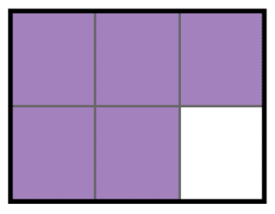

1. 5/6
2. 4/5
3. 1/6
4. 5/4

Question 23: What is the fraction shown? (Note: Golden Rule)

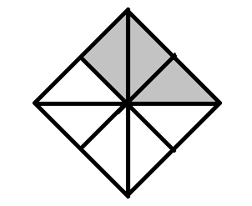

1. 4/8
2. 3/5
3. 4/6
4. 3/8

Question 24: What is the Numerator?

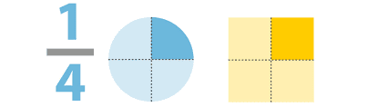

1. The square
2. The circle
3. 4
4. 1

Question 25: What fraction is represented in this image? (Note: Golden Rule)

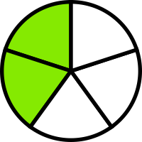

1. 2/6
2. 2/5
3. 1/3
4. 2/4

Question 26: 2/4 = 6/12

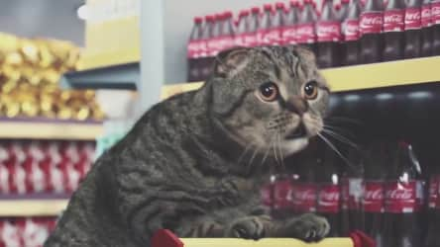

1. True
2. False
3. I have no clue
4. Pineapple

Question 27: 3 1/3 = 9/3

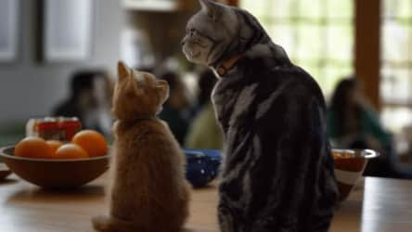

1. True
2. False
3. Why?
4. Fractions are fun!

Question 28: The Golden Rule is when we change fractions from improper to mixed.



1. True
2. False
3. Blueberry
4. Improper fractions? What’s that?

Question 29: Which of the following is an improper fraction?

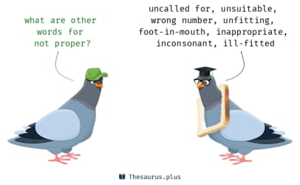

1. 2/3
2. 3/5
3. 9/7
4. 9/10

Question 30: What is half of 6/8?

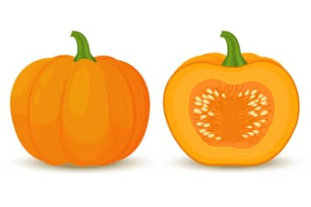

1. 3/8
2. 3/4
3. 4/6
4. 2/8

Question 31: What is the GCF (Greatest Common Factor) of 45 and 36?



1. 2
2. 6
3. 9
4. 12

Question 32: What is the GCF (Greatest Common Factor) of 48 and 34?



1. 2
2. 4
3. 6
4. 8

Question 33: What is the Lowest Common Denominator of 1/2 and 1/6?

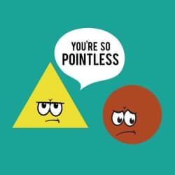

1. 6
2. 2
3. 12
4. 3

Question 34: How many halves in 3 wholes?

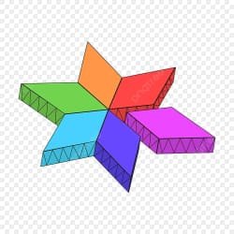

1. 2
2. 4
3. 6
4. 8

Question 35: A type of fraction that has a larger numerator than its denominator

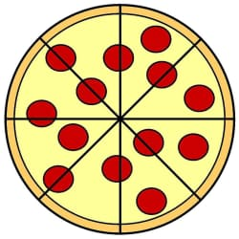

1. Proper fraction
2. Improper fraction
3. Mixed number
4. Simplified fractions

Question 36: Write 2/5 as a percent

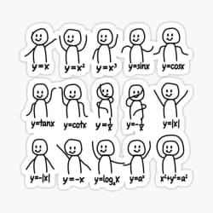

1. 20%
2. 25%
3. 30%
4. 40%

Question 37: Convert 90% to a fraction

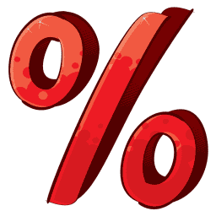

1. 8/9
2. 9/10
3. 9
4. 1/9

Question 38: Convert 1/4 to a decimal

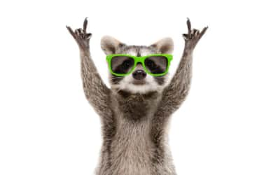

1. 0.2
2. 0.1
3. 0.33
4. 0.25

Question 39: Convert 4/8 to a decimal

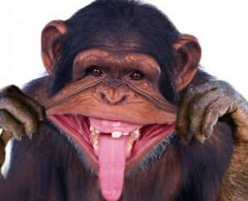

1. 0.25
2. 0.125
3. 0.5
4. 0.2

Question 40: Convert 0.3333333333333333 to a fraction

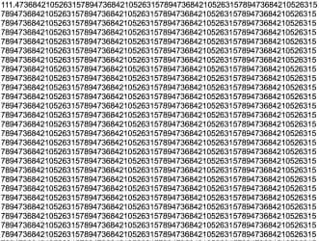

1. 1/3
2. 2/3
3. 3/4
4. 1/6

Question 41: Convert 30% to a decimal.



1. 0.3
2. 0.03
3. 0.25
4. 0.6

Question 42: If Ms. Lapointe has 5 cookies, how many would each student get if she equally divides them between 20 students. (Note: Golden Rule)

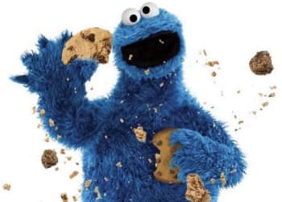

1. 20/5
2. 5/20
3. 1/4
4. 1/2

Question 43: What percent of the class has no cookies if 40% of the class has cookies?

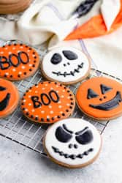

1. 40%
2. 20%
3. 60%
4. 100%

Question 44: Mr. Fitch has 1 cookie and Ms. Lapointe has 7/2 cookies. How many do they have as a MIXED fraction?

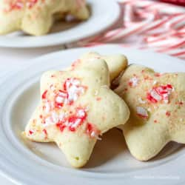

1. 9.2
2. 4 1/2
3. 3 1/2
4. 4

Question 45: What is 1/2 + 1/4 as a percent?

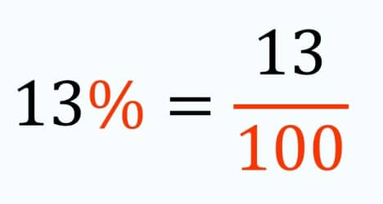

1. 75%
2. 25%
3. 50%
4. 100%

Question 46: Ms. Lapointe has 1/2 of a cookie. She gets 50% more cookies, how many does she have?

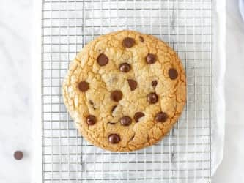

1. 1/2
2. 1
3. 3/4
4. 1/4

Question 47: If Ricky Bobby got 18/20 on his math test what was his grade?



1. GOOD JOB RICKY!
2. 90%
3. 85%
4. 80%

Question 48: If you have a quarter of water left and you fill it up to three quarters, how much water did you add?



1. 1/4
2. 1/2
3. 1
4. 1/3

Question 49: Represent the image as a percent, decimal and fraction.

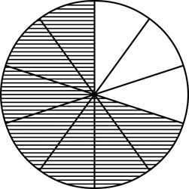

1. 70%, 0.07, 7/100
2. 60%, 0.6, 6/10
3. 70%, 0.7, 7/10
4. 60%, 0.06, 6/10

Question 50: Simplify 24/36



1. 2/3
2. 2/6
3. 5/7
4. 4/8

Question 51: The number on the bottom of the fraction is called the

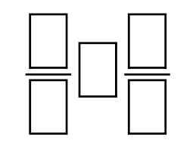

1. Denominator
2. Numerator
3. Terminator
4. Exterminator