**3D GEOMETRY – ANSWERS**

Question 1: A 3D shape with one circular base:



1. Cone
2. Cylinder
3. Sphere
4. Pyramid

Question 2: A 3D shape with two circular bases:

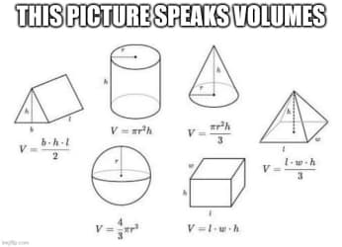

1. Cone
2. Cylinder
3. Sphere
4. Pyramid

Question 3: A 3D shape with one square base:

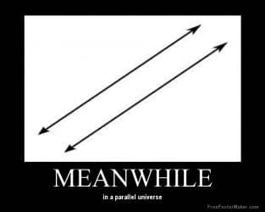

1. Rectangular prism
2. Cube
3. Rectangular pyramid
4. Triangular prism

Question 4: A 3D shape with four triangular faces:

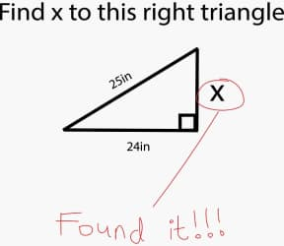

1. Triangular prism
2. Polyhedron
3. Pentagon
4. Triangular pyramid

Question 5: A 3D shape with parallel polygonal bases:

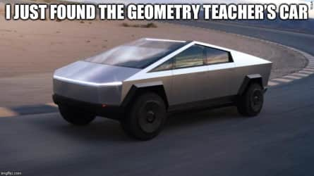

1. Prism
2. Pyramid
3. Cylinder
4. Cone

Question 6: Which 3D shape is this?

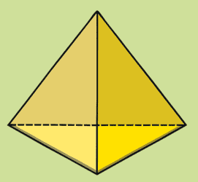

1. Triangular prism
2. Triangular pyramid
3. Rectangular prism
4. Rectangular pyramid

Question 7: Which 3D shape is this?

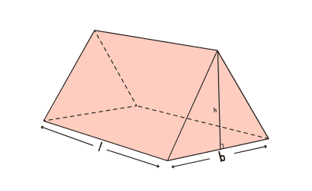

1. Rectangular prism
2. Triangular pyramid
3. Triangular prism
4. Rectangular pyramid

Question 8: Which 3D shape is this?

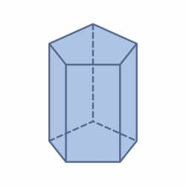

1. Rectangular prism
2. Pentagonal prism
3. Hexagonal pyramid
4. Triangular pyramid

Question 9: Which 3D shape is this?

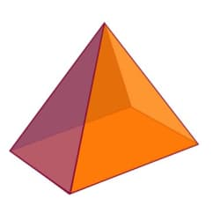

1. Rectangular prism
2. Triangular prism
3. Rectangular pyramid
4. Triangular pyramid

Question 10: Two parallel and congruent bases connected by polygonal sides:

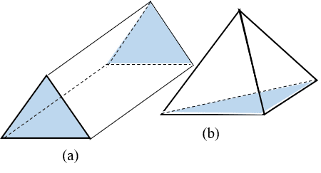

1. Prism
2. Pyramid

Question 11: A single base connected with triangular sides:



1. Prism
2. Pyramid

Question 12:

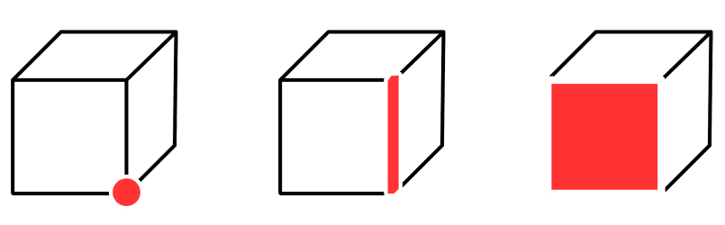

1. Edge
2. Vertex
3. Face
4. Side

Question 13: The segment where two faces meet:



1. Edge
2. Vertex
3. Face
4. Side

Question 14: The flat surface of a 3D shape:



1. Edge
2. Vertex
3. Face
4. Side

Question 15: Which 3D shape is this?

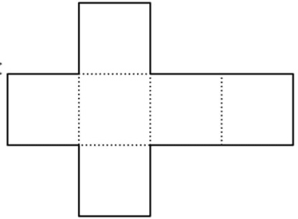

1. Cube
2. Pyramid
3. Cross
4. Rectangular prism

Question 16: Which 3D shape is this?

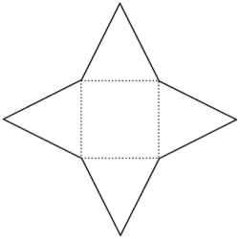

1. Triangular prism
2. Rectangular pyramid
3. Triangular pyramid
4. Rectangular prism

Question 17: Which 3D shape is this?

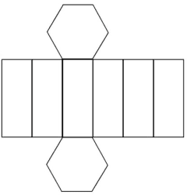

1. Hexagonal pyramid
2. Rectangular pyramid
3. Hexagonal prism
4. Rectangular prism

Question 18: Which 3D shape is this?

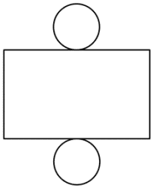

1. Rectangular prism
2. Sphere
3. Cube
4. Cylinder

Question 19: Which 3D shape is this?

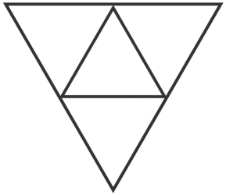

1. Triangular pyramid
2. Triangular prism
3. Triangle
4. Polyhedron

Question 20: A 2D shape with two pairs of parallel sides:



1. Rectangle
2. Prism
3. Triangle
4. Square

Question 21: A closed 2D figure formed by 3 or more line segments:

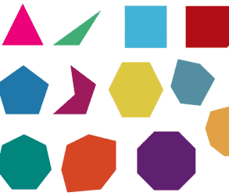

1. Rectangle
2. Quadrilateral
3. Polygon
4. Polyhedron

Question 22: A closed 3D figure formed with polygonal faces: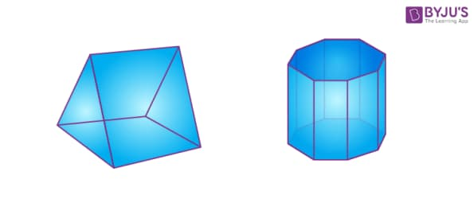

1. Prism
2. Quadrilateral
3. Polygon
4. Polyhedron

Question 23: Every rectangle is a square.

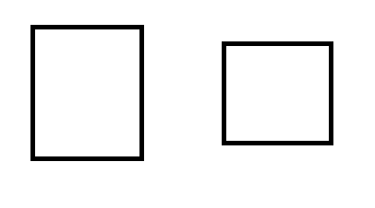

1. True
2. False

Question 24: Every square is a rectangle.



1. True
2. False

Question 25: Surface area is measured in:

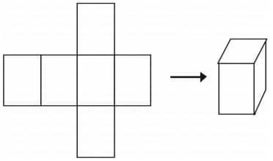

1. Squared units
2. Centimetres
3. Football fields
4. Cubed units

Question 26: Volume is measured in:



1. Squared units
2. Centimetres
3. Football fields
4. Cubed units

Question 27: The formula for the surface area of a rectangular prism:

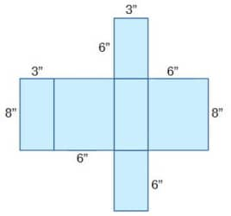

1. *SA = 2(lw + lh + hw)*
2. *SA = l x w x h*
3. *SA = a²*
4. *SA = l x h*

Question 28: The formula for the volume of a prism:

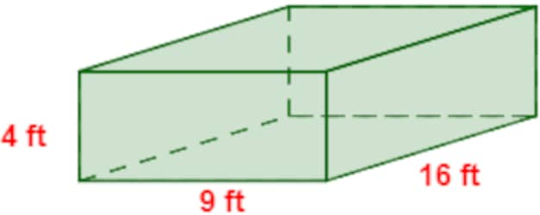

1. *V = l x w*
2. *V = l x w x h*
3. *V = a²*
4. *V = ½l x w x h*

Question 29: The formula for the volume of a cylinder:

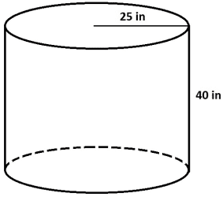

1. *V = l x w*
2. *V = l x w x h*
3. *V = a²*
4. *V = πr²h*

Question 30: The formula for the surface area of a cylinder:

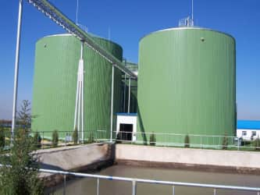

1. *SA = 2πr(r + h)*
2. *SA = 2πr²*
3. *SA = 2(lw + lh + wh)*
4. I don’t know

Question: Calculate the surface area.

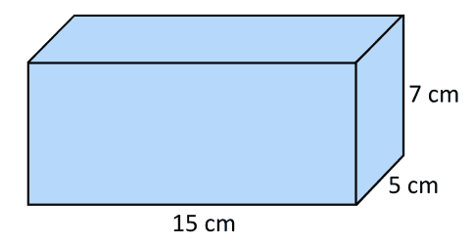

1. 215cm²
2. 430cm²
3. 230cm²
4. 430cm³

Question 32: Calculate the volume:



1. 430 cm³
2. 525 cm²
3. 430 cm²
4. 525 cm³

Question 33: How many vertices does a cube have?

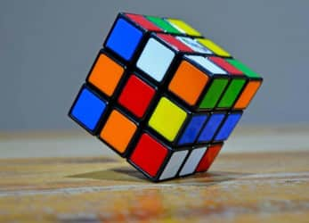

1. 4
2. 8
3. 2
4. 16

Question 34: How many edges does a cube have?



1. 4
2. 8
3. 12
4. 16

Question 35: How many faces does a cube have?



1. 4
2. 6
3. 8
4. 12

Question 36: How many vertices does a cylinder have?

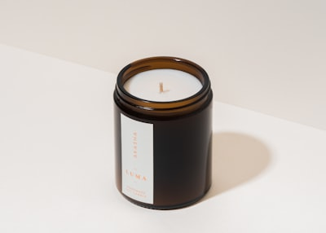

1. 0
2. 1
3. 2
4. 8

Question 37: How many edges does a cylinder have?

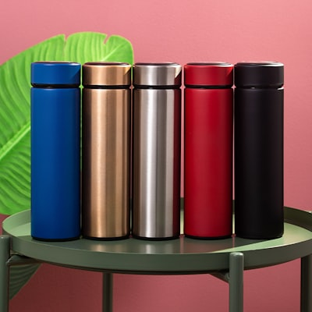

1. 0
2. 2
3. 1
4. 4

Question 38: How many faces does a cylinder have?

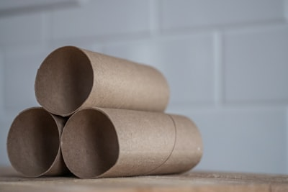

1. 0
2. 1
3. 2
4. 3

Question 39: How many faces does a cone have?



1. 0
2. 1
3. 2
4. 3

Question 40: How many vertices does a cone have?



1. 0
2. 1
3. 2
4. 3

Question 41: How many edges does a cone have?



1. 0
2. 1
3. 2
4. 3

Question 42: How many vertices does a sphere have?



1. 0
2. 1
3. 2
4. 3

Question 43: How many edges does a sphere have?



1. 0
2. 1
3. 2
4. 3

Question 44: How many faces does a sphere have?



1. 0
2. 1
3. 2
4. 3

Question 45: Calculate the volume.

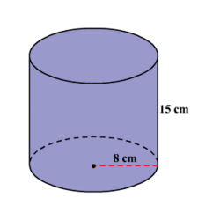

1. 3014 cm³
2. 1156 cm³
3. 3014 cm²
4. 754 cm³

Question 46: Calculate the surface area.



1. 240cm²
2. 120cm²
3. 3014cm²
4. 1156cm²

Question 47: Calculate the volume:

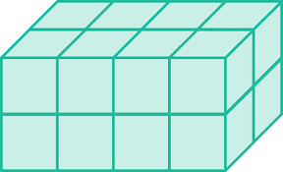

1. 6 cubic units
2. 12 squared units
3. 18 squared units
4. 32 cubed units

Question 48: Calculate the surface area.



1. 12 cubic units
2. 40 squared units
3. 32 squared units
4. 32 cubic units

Question 49: Congruent means similar shape and size.

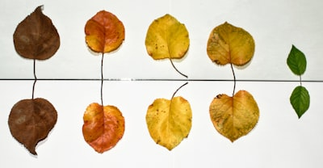

1. True
2. False

Question 50: I have 4 vertices, 6 edges, and 4 faces. Which 3D shape am I?

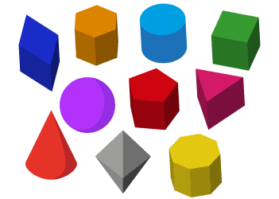

1. Rectangular pyramid
2. Cylinder
3. Cube
4. Triangular pyramid

Question 51: I have 0 vertices, 2 edges, and 3 faces. Which 3D shape am I?



1. Rectangular pyramid
2. Cylinder
3. Cube
4. Triangular pyramid

Question 52: I have 8 vertices, 12 edges, and 6 faces. Which 3D shape am I?



1. Rectangular pyramid
2. Cylinder
3. Cube
4. Triangular pyramid

Question 53:

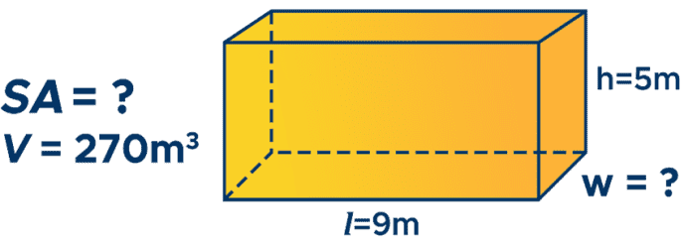

1. 3m
2. 30m
3. 6m
4. 45m