Plot Diagrams

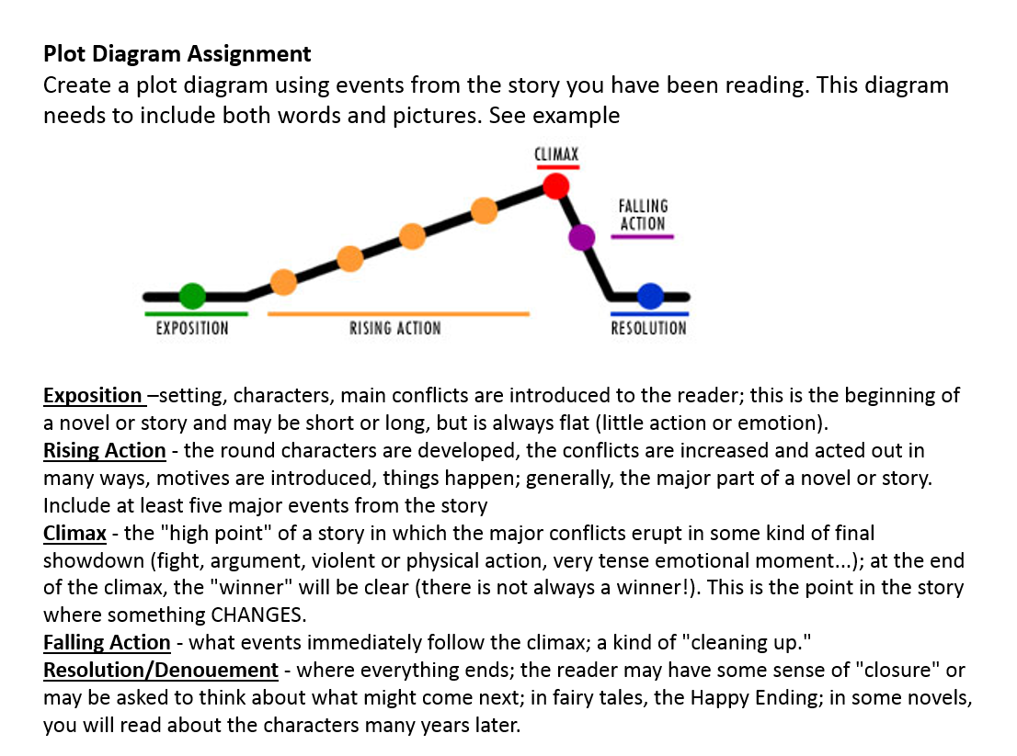

| **Antagonist:** The antagonist is a person who actively opposes or is hostile to the protagonist. In many stories the antagonist takes on the form of the bad guy in a story.  **Protagonist:** the leading character. This character often takes on the role of the good guy, but this isn’t an essential attribute of a protagonist. The word protagonist is a [noun](https://writingexplained.org/grammar-dictionary/noun).  **Situation/Climate:** Is a part of the exposition in a story. It’s what's going on when we meet the characters, history and mood at the beginning.  **Theme:**  The underlying meaning of a story. It is the message the writer is trying to convey through the story. Often the theme of a story is a broad message about life. The theme of a story is important because a story's theme is part of the reason why the author wrote the story. |
| --- |

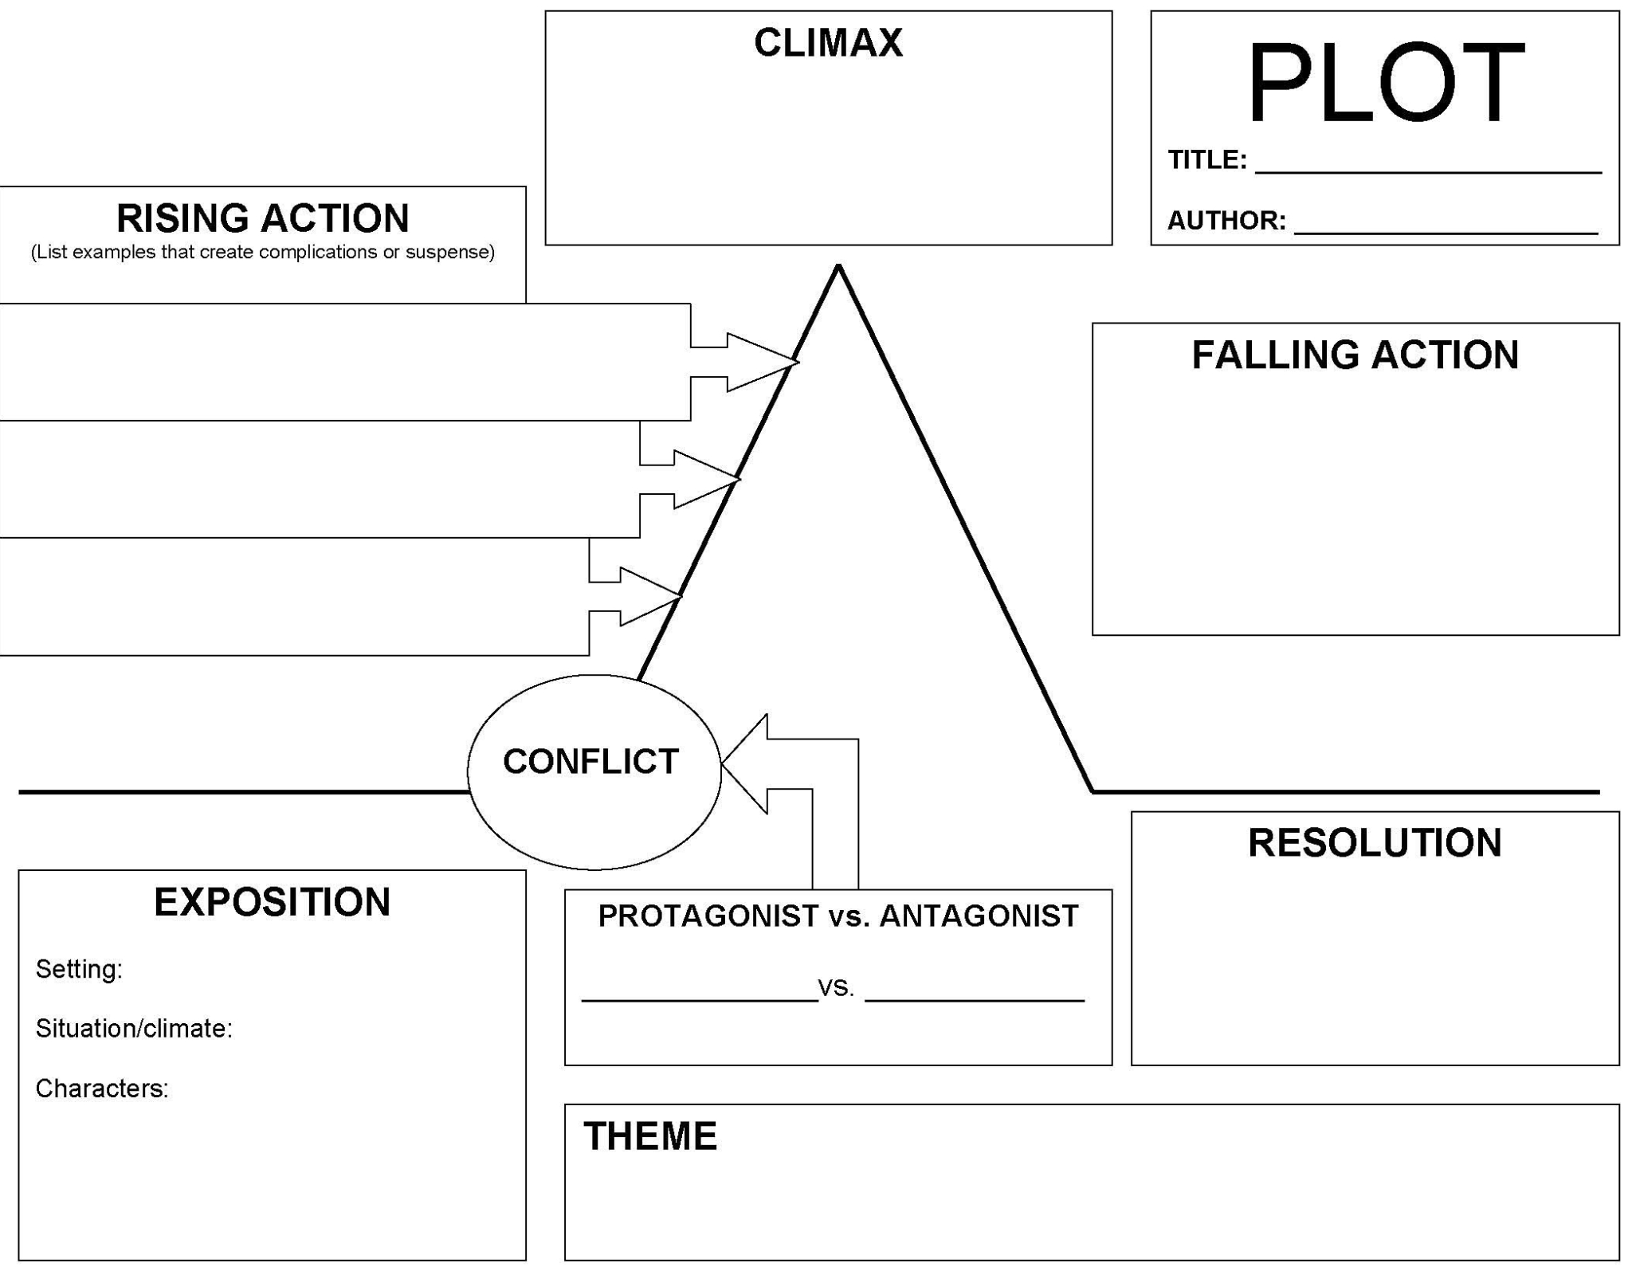

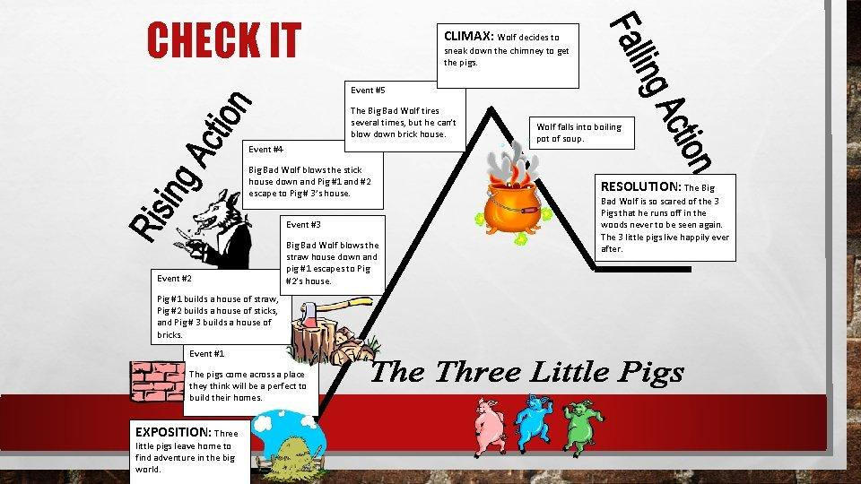

Characters:

3 pigs and wolf