**FINANCIAL LITERACY BLOOKET 2 – ANSWERS**

**Question 1:** What is *simple interest*?

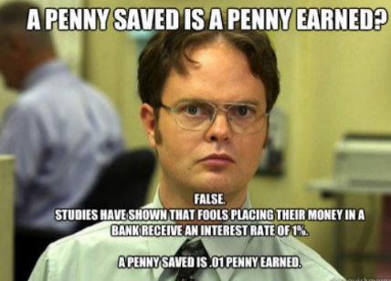

1. The state of wanting to know or learn about something or someone.
2. The advantage or benefit of a person or group.
3. The amount of money paid or earned for the use of money.
4. Excite the curiosity or attention of someone.

**Question 2:** What is the formula to find simple interest?

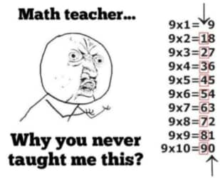

1. A+b = c
2. I = Prt
3. C = πd
4. A = πr2

**Question 3:** What is PRINCIPAL?



1. The amount of money invested or borrowed
2. A mathematical that contains an equals sign
3. The amount by which the regular price an item is reduced
4. The distance across a circle through its center

**Question 4:** What is RATE?



1. The percentage of the value of a balance or debt that one pays or is paid each time period
2. A ratio of two measurements having different units
3. One outcome or a collection of outcomes
4. The multiplicative inverse of a number

**Question 5:** What does the variable t stand for in the formula: I=prt.



1. Turtle
2. Time
3. Theoretical probability
4. Truffle

**Question 6:** What is COMPOUND INTEREST?

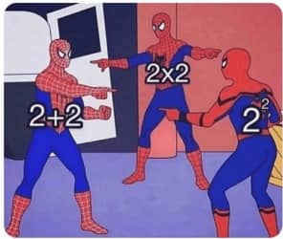

1. Two or more simple events
2. The numerical part of a term that contains a variable
3. Interest paid of the initial principal and on interest in the past
4. A term without a variable

**Question 7:** Find the simple interest: $4 400 at 10% for 2 years



1. $88.00
2. $8 800.00
3. $880.00
4. $5 280.00

**Question 8** Find the simple interest: $800 at 8% for 3 years

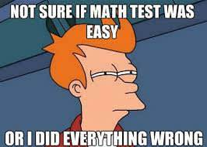

1. $1 920.00
2. $19.00
3. $992.00
4. $192.00

**Question 9:** Find the total amount of money compounded annually. $840 at 7% for 4 years

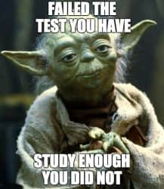

1. $1 101.07
2. $1 101.74
3. $1 101.00
4. $1 101.82

**Question 10:** What does “**I**” represent in the Simple Interest Formula? I = Prt



1. Principal
2. Rate
3. Interest
4. Time

**Question 11:** What does "**r**" represent in the Simple Interest Formula? I = Prt

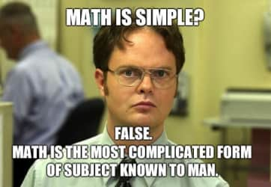

1. Rate
2. Interest
3. Time
4. Account balance

**Question 12:** What does "**t**" represent in the Simple Interest Formula? I = Prt

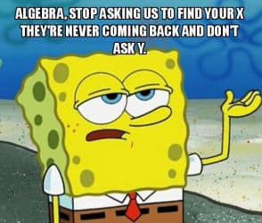

1. Time
2. Principal
3. Interest
4. Rate

**Question 13:** What does "**P**" represent in the Simple Interest Formula? I = Prt

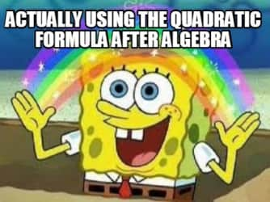

1. Principal
2. Farmer Brown
3. Pringles
4. Rate

**Question 14:** Calculate the Simple INTEREST. Principal = $8 000 Rate = 5% Time = 2 years

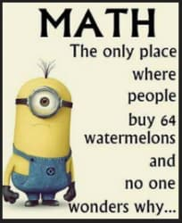

1. $8
2. $80
3. $800
4. $888

**Question 15:** The Simple Interest Formula I = Prt calculates what

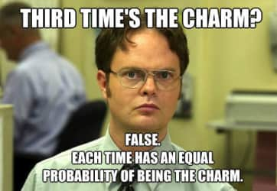

1. The Total Account Amount
2. Interest
3. The rate
4. The Principal

**Question 16:** The [Compound Interest Formula](https://downwindkennels.com/me/images/interestformulas.jpg) that we use calculates the...



1. Interest only
2. Balance
3. Principal (the original amount)
4. Rate (as a decimal)

**Question 17:** What is the interest to be paid on a 3 year, $13 000 loan at 4% simple interest?

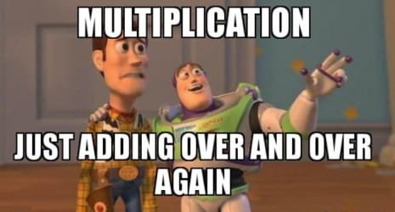

1. $2 500
2. $1 700
3. $1 400
4. $1 560

**Question 18:** What is the interest to be paid on a 10 year, $40 000 loan at 4.5% per annum?

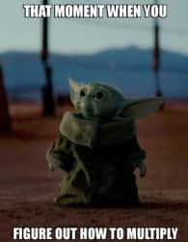

1. $18 500
2. $18 000
3. $18 400
4. $18 300

**Question 19:** What is the total amount to be paid on a $13000 loan over 3 years at a 4% interest rate?

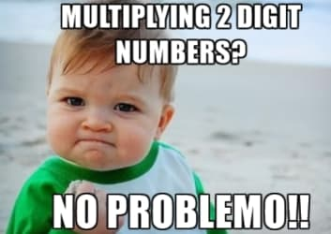

a. $14 560

1. $14 000
2. $15 560
3. $16 560

**Question 20:** Which is **NOT** a type of tax that Canadians pay?



1. Sales Tax
2. Income Tax
3. Windfall Tax
4. Property Tax