The pH Scale Quiz

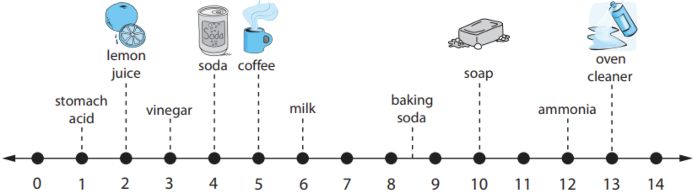

1. What is the pH scale used for?
a) It tells you if water has electrons.
b) It tells you if a solution is an acid, a base, or neutral.
c) It tells you the temperature of a liquid.
d) It tells you how long it will take to get to Grandma’s house.

2. Water is a ____ on the pH scale.
a) 0  b) 7 | c) 11  d) 14

3. Vinegar is ________.
a) Acidic  b) Basic | c) Neutral  d) All of the above

4. Soap is ________.
a) Acidic  b) Basic | c) Neutral  d) All of the above

5. Ammonia is more ______ than soap.
a) Acidic  b) Basic | c) Neutral  d) None of the above

6. Soda is how much more acidic than coffee?
a) 10 times  b) 100 times | c) 1,000 times  d) 10,000 times

7. Stomach acid is how much more acidic than vinegar?
a) 10 times  b) 100 times | c) 1,000 times  d) 10,000 times

