The pH Scale Quiz

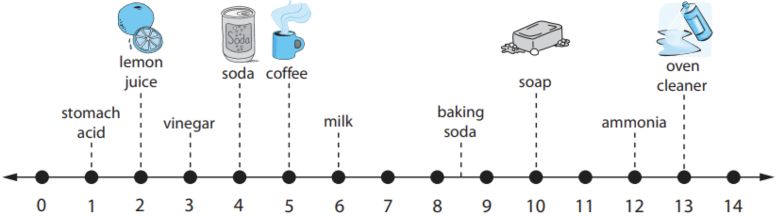

1. What is the pH scale used for?

2. An increase or decrease by 1 integer on the pH scale corresponds to a 10-fold change in the concentration of H⁺ ions.
a) True
b) False

3. Solutions with a very low pH produce lots of OH⁻ ions.
a) True
b) False

4. Water is a ______ on the pH scale.
a) 0  b) 7 | c) 11  d) 14

5. Vinegar is ______.
a) Acidic  b) Basic | c) Neutral  d) None of the above

6. Soap is ______.
a) Acidic  b) Basic | c) Neutral  d) None of the above

7. Ammonia is more ______ than soap.
a) Acidic  b) Basic | c) Neutral  d) None of the above

8. Soda is how much more acidic than coffee?
a) 10 times  b) 100 times | c) 1,000 times  d) 10,000 times

9. Oven cleaner is how much more basic than soap?
a) 10 times  b) 100 times | c) 1,000 times  d) 10,000 times

10. Stomach acid is how much more acidic than vinegar?
a) 10 times  b) 100 times | c) 1,000 times  d) 10,000 times

