PROPERTIES OF ACIDS:
- Corrosive, Sour & pH < 7
- Reacts with metals to produce salt and hydrogen gas
- Acids are electrolytes (Regulate nerve & muscle function / muscles are “electric tissues”)
- Dissolves in water to produce H+ ions (ion = molecule/atom with a net electric charge due to the loss or gain of electrons) Electron: negative charge

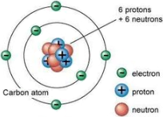

STRONG ACIDS:
1. Sulfuric Acid 2. Nitric Acid 3. Hydrochloric Acid

WEAK ACIDS:
1. Acetic Acid (vinegar) 2. Citric Acid (sour candies) 3. Carbonic Acid (soda pop)

PROPERTIES OF BASES/ALKALIS:
- Corrosive, Bitter & pH >7
- Slippery (react with fatty acids in your skin, makes a bit of “soap”)
- Reacts with oils & fats
- Bases neutralize acids to produce salt & water
- Dissolves in water to produce OH- ions

