pH Calculations
1. What common liquid could be represented by the arrow in the above image?

2. What terms do we use to describe the four brackets in the above image?

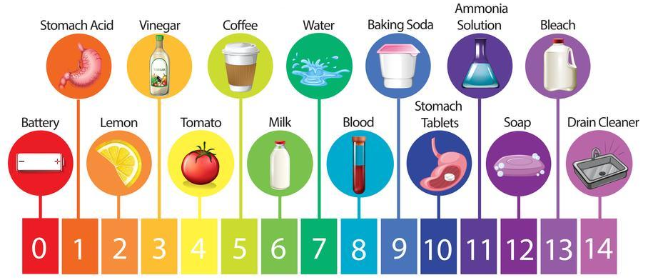
3. Stomach acid is how much more acidic than vinegar?

4. Baking soda is how much more basic than coffee?

5. Drain cleaner is how much more basic than blood?

6. Lemon juice is how much more acidic than stomach tablets?

7. Use the examples from the pH scale on the other side of this page to create at least FIVE NEW pH statements. Use the sentence structure that we have been practicing, “____________ is ____________ times more ____________ than ____________.”

8. What is another term for “basic”?

9. The pH scale is not a linear scale, it is a _________________________ scale.
pH Calculations
1. What common liquid could be represented by the arrow in the above image?

Water (H₂O)

2. What terms do we use to describe the four brackets in the above image?

From left to right: Strong acids, weak acids, weak bases, strong bases.

3. Stomach acid is how much more acidic than vinegar?

Moving 2 units from pH 1 to pH 3, so 10² = 100.
Stomach acid is 100 times more acidic than vinegar.

4. Baking soda is how much more basic than coffee?

Moving 4 units from pH 9 to pH 5, so 10⁴ = 10,000.
Baking soda is 10,000 times more basic than coffee.

5. Drain cleaner is how much more basic than blood?

Moving 6 units from pH 14 to pH 8, so 10⁶ = 1,000,000.
Drain cleaner is 1,000,000 times more basic than blood.

6. Lemon juice is how much more acidic than stomach tablets?

Moving 8 units from pH 2 to pH 10, so 10⁸ = 100,000,000.
Lemon juice is 100,000,000 times more acidic than stomach tablets.

7. Use the examples from the pH scale on the other side of this page to create at least FIVE NEW pH statements. Use the sentence structure that we have been practicing, “____________ is ____________ times more ____________ than ____________.”

Answers will vary for this question.
Ex: Milk is 100,000 times more acidic than ammonia solution.

8. What is another term for “basic”?

Another term for basic is alkaline.

9. The pH scale is not a linear scale, it is a _________________________ scale.

It is a logarithmic scale.

