 | Grade 7 Science | 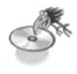
 | Structural Strength & Stability
Name: _________________________
Homeroom:
DESIGN CHALLENGE: NEWSPAPER CD RACK
AIM: Use only newspaper & 1 roll of masking tape to build a CD rack. It must be able to hold 5 CD’s. It must be stackable so that a second rack can be placed on top or underneath your rack. It must store CDs safely. You must be able to take out one CD at a time. Decorate the rack. Make it look nice.

TECHNICAL DRAWING: In pencil (min. ½ page in size). (Blank / graph paper, metric measurements, title & list the “view”). Minimum of 1 view (3D, Top, Front or Side). Label Features.

QUESTIONS (Answer in full, multiple sentences.)

- How many of your racks do you think you could stack? How could you test the structure without damaging any CD’s?
- How much tape & newspaper did you use? Consider if you had to build another rack, how could you reduce the amount of materials used?
- Would your structure be different if you were limited to using 5m of tape? Explain.
- Examine the racks made by your classmates & examples from previous years. Do any of them give you ideas for improving the design of your own rack? Compare.
- How successful were you at improving the appearance of your rack? Could you make a CD rack made of newspaper that someone would be willing to buy? Explain.
- Write an explanation paragraph that summarizes what problems you encountered, ideas for future improvements and modifications. Include detailed test comments.
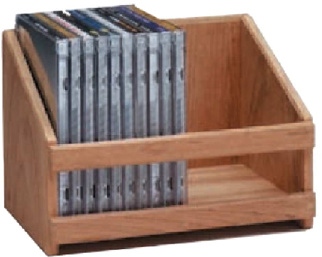

FOLK’S / GUARDIAN’S SIGNATURE __________________________ Read over & get signed at the start.

BUDDY CHECK SIGNATURE _________________________________At the end, your buddy will suggest improvements or point out missing items.

Assigned: _________________________ Due Date: ________________________

SUGGESTIONS: Type it out. Include 3 diagram views. Photograph the process. Make a title page.

