Assignment: Analyzing and Making Cartograms

Part 1: Analyzing Cartograms

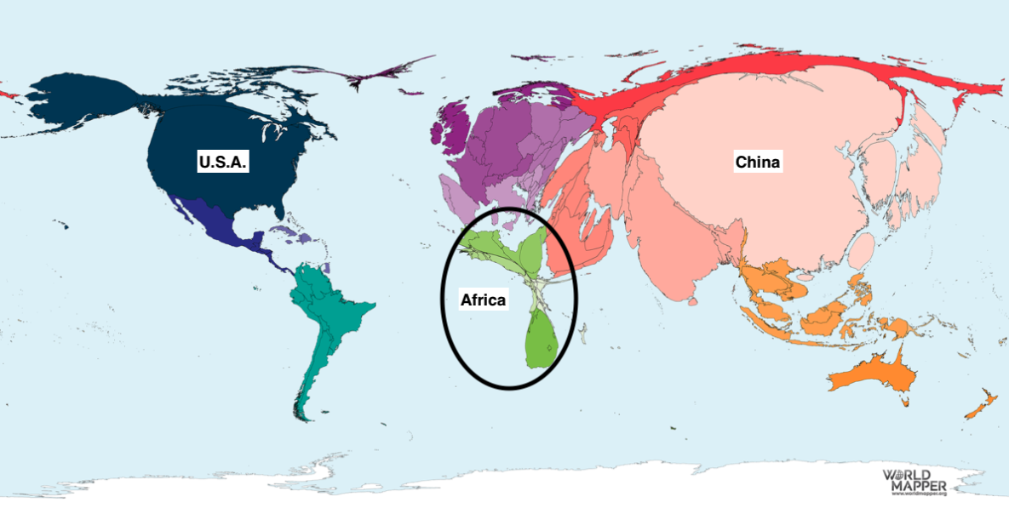
Figure 1: Carbon dioxide (CO₂) emissions in 2015

Look at Figure 1 above, it is a cartogram that represents the carbon dioxide emissions from each country in 2015. The United States of America, China, and the continent of Africa are all labeled. Answer the following questions using Figure 1.

1. Which country is the largest? Does this country produce the most carbon dioxide or the least?

2. Look at the continent of Africa, notice how small some African countries are. Why do you think that some countries in Africa produce so little carbon dioxide?

3. Now focus on China and the United States of America. Why do you think these countries are so large?

4. Do a little bit of research on the effects of carbon dioxide in the atmosphere. Do you think that stricter regulations should be put in place to decrease the amount of carbon dioxide produced by each country? Why or why not?

Part 2: Making Cartograms
Using the “Go Cart” website (https://go-cart.io/cartogram) and following the same steps as we did in class (also outlined on the next page), make a cartogram that represents the GDP (gross domestic product, the value of all the goods and services produced in a certain time period) for the Canadian provinces and territories using the data provided to you in the following table.

Province or Territory | GDP
British Columbia | 271789000000
Alberta | 347102000000
Saskatchewan | 86611000000
Manitoba | 68060000000
Ontario | 798213000000
Quebec | 407590000000
New Brunswick | 33568000000
Nova Scotia | 41453000000
Prince Edward Island | 6644000000
Newfoundland and Labrador | 34075000000
Yukon | 2757000000
Northwest Territories | 4517000000
Nunavut | 3161000000

Step 1: In “Select Map”, change the country to Canada.

Step 2: Click on “Edit”.

Step 3: A new window will open, you will see a table that looks like the one below. In the column titled “GDP” enter the updated data from the table above for each province and territory. You can copy the number from the table and then paste it to ensure you don’t miss any zeroes.

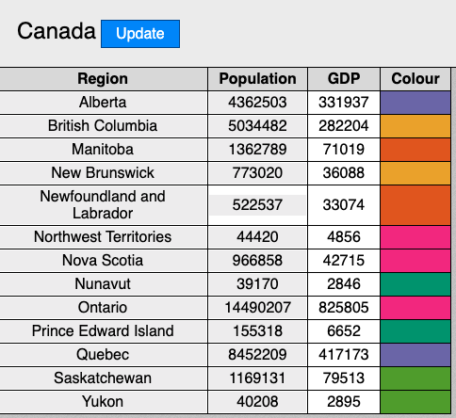

Step 4: Click on the blue “Update” button in this window.

Step 5: Back in the first window, a pie chart will appear. Click the “Yes, I Confirm” button.

Step 6: Your cartogram for the GDP of Canadian provinces and territories will appear on the right. Use the snipping tool to take a screenshot of the cartogram and insert it in this document.

